Gaze-awareness for Videoconferencing: A Software Approach

Jim Gemmell
C. Lawrence Zitnick
Thomas Kang
Kentaro Toyama
Steven Seitz

Abstract
Many desktop videoconferencing systems are ineffective due to deficiencies in gaze awareness and sense of spatial relationship. Previous works employ special hardware to address these problems. Here, we describe a software-only approach. Heads and eyes in the video are tracked using computer-vision techniques, and the tracking information is transmitted along with the video stream. Receivers take the tracking information corresponding to the video and graphically place the head and eyes in a virtual 3D space such that gaze awareness and a sense of space are provided.

Introduction
In most videoconferencing systems it is impossible for participants to make eye contact, or to infer at whom or what the other participants are gazing. This loss of gaze awareness has a profound impact on the communications that take place. In the past, only special hardware allowed gaze-awareness to be restored. We have developed an approach to videoconferencing gaze-awareness that is achieved through software only.
The impact of gaze is striking: we all know the experience of “feeling watched” when we perceive gaze in our peripheral vision. It is hard to resist the urge to look at someone who is staring at you. In face-to-face communication, gaze awareness, and eye contact in particular, are extremely important [Arg88]. Gaze is used as a signal for turn taking in conversation [Novick]. People using increased eye contact are perceived as more attentive, friendly, cooperative, confident, natural, mature, and sincere. They tend to get more help from others, can generate more learning as teachers, and have better success with job interviews.
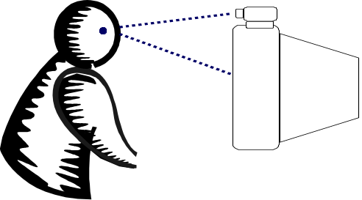
Figure 1 - Gaze directed at display, not at camera.
The loss of gaze-awareness in typical videoconferencing systems stems from the fact that when a participant is looking at someone’s image on his display, they are not looking into the camera, which is typically mounted above, below or beside the display (Figure 1). Someone who is not looking into the camera will never be perceived as making eye contact with you no matter where you are situated relative to the display (Figure 2a). Conversely, someone looking directly into the camera will always be perceived as making eye contact, even as your orientation to the display changes. A famous example is Mona Lisa’s eyes “following” you around the room (Figure 2b).

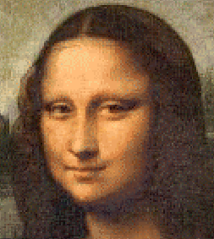
(a) (b)
Figure 2 – (a) Not looking at camera; no eye-contact. (b) Looking at the camera – eye contact.
Besides lack of direct eye contact between two parties, multi-party desktop systems provide no sense of space, nor any awareness that someone is gazing at a third party. Video for each participant is in an individual window, placed arbitrarily on the screen, so they also never appear to look at other participants (Figure 3).
The remainder of this paper describes a software approach to supporting gaze-awareness in videoconferencing. Section 2 reviews previous research on gaze and videoconferencing. Section 3 outlines the architecture of our videoconferencing system. Section 4 discusses how we render participants in a virtual 3D space. Section 5 explains the computer-vision aspect of the system. Section 6 concludes and outlines our future plans.
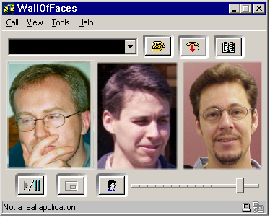
Figure 3: Videoconferencing: The typical videoconferencing interface does not provide gaze awareness or spatial relationships among participants

Previous work

Gaze
People tend not to gaze fixedly at someone’s eyes. Gaze is usually shifted from one point to another around the face about every 1/3 second, and is primarily directed around the eyes and mouth [Arg88]. Mutual gaze is typically held for no more than one second and does not require actual eye-contact, but can be directed anywhere in the region of the face. In fact, people are not that good at detecting actual eye contact, while they are fairly accurate at detecting face-directed gaze [Arg88, Mor92]. Accuracy reduces with distance as well as deviation from a head-on orientation [Arg88, Ant69, Rim76, Nol76]. It seems likely that gaze direction is determined primarily by the position of the pupil in the visible part of the eye [Ant69].
The perception of head pose seems to be heavily influenced by the region around the eyes and nose (perhaps because most gaze is directed there, as mentioned above). This is illustrated in Figure 4, which shows a cutout of the eyes and nose turned to the right superimposed on a face that is oriented towards the viewer. At first glance, the entire head seems to be oriented to the right. The visible parts of the left and right profile lines of the face may also be used as important cues in perceiving head pose, as demonstrated by an experiment which changes room lighting [Tro98].

Figure 4: Eyes and nose superimposed on face - at first glance the head seems turned to the right.
People definitely notice the difference between receiving gaze 15 percent of the time versus 85 percent of the time. Experiments found that those using more gaze gained more job offers in interviews, received more help when asking, are more persuasive, and can generate more work and learning from students as a teacher. People using more gaze are seen as friendly, self-confident, natural, mature, and sincere, while those with less gaze are seen as cold, pessimistic, cautious, defensive, immature, evasive, submissive, indifferent, and sensitive. Individuals look at each other more when cooperating than competing [Arg88].
Speakers glance at listeners to elicit responses from them, but more importantly to obtain information about the listener, especially to see expressions, head nods, and other signals. The listener gaze direction is important in this context: to whom is that smile or wink directed? An "eye flash", lasting about 3/4 second, can also be used as a point of emphasis. Listeners typically look 70-75 percent of the time, in 7-8 second glances. They are looking for non-verbal communication, and also doing some lip reading (a clear view of the lips can make up for several dB of noise) [Arg88]. In groups of three, gaze is divided between the other two parties, and mutual gaze only occurs about 5 percent of the time. Gaze is used to co-ordinate turn-taking in conversation, but is not always the only or most important cue [Novick].

Videoconferencing and gaze
The advent of videoconferencing is generally dated at 1927 with the research of Ives at Bell labs [Sto69]. Since then, videoconferencing has been repeatedly hailed as about to become ubiquitous: at the introduction of PicturePhone at the 1964 World’s Fair, with the introduction of ISDN videoconferencing in the 1980’s, and with the introduction of cheap desktop videoconferencing in the 1990’s. However, it has never caught on as well as expected.
Some studies that looked at group problem solving or task-accomplishment found no advantage in video over an audio-only communication. [Cha72] compared communicating face to face with communicating via voice only, via handwriting, and via typing for problem solving. They found that for problem solving, voice is only a little slower than face to face, and everything else takes at least twice as long. The fact that voice is nearly as fast as face to face seems to imply that video is not necessary. A similar study by [Gale91] compared data sharing, data sharing with audio, and data sharing with audio and video. They also found no difference in task completion time or quality. [Sel95] also found no significant contribution from video. [Ack87] found that people were happy with gaze-aware videoconferencing as a medium, but that it did not improve the final outcome of the task given.
To some, such studies combined with negative experiences prove that videoconferencing is not worthwhile. However, many systems have suffered from audio latencies and difficult call setup that have contributed to the negative results. Furthermore, it is not clear that solving contrived problems is the true test of videoconferencing. If video contributes to enhanced communications it may show its value in other settings such as negotiations, sales, and in relationship building. In fact, among these very studies are observations that the “rate of social presence” is increased by video [Gale91] and that people took advantage of gaze awareness in a system that supported it [Sel95].
A number of studies have speculated that spatial audio and video are needed to replicate the conversational process [Hun80, Oco97, Ver99]. PicturePhone was redesigned in the late 60’s, with steps taken to reduce the “eye-contact angle”, which they believed becomes perceptible after about 5 degrees [Sto69]. A study of a point-to-point system with 2 or 4 people at each end found that correcting gaze improved the perception of non-verbal signals [Swu97].
Gaze-aware videoconferencing systems have been supported by hardware techniques such as half-silvered mirrors, pinhole cameras in displays [Rose95, Oka94, Ack87]. The Virtual Space and Hydra systems support gaze-awareness by deploying a small display/camera for each party, placed far enough away from the user that the angle between the camera and images on the display is not noticeable [Hun80, Sel95].
The Teleport system does not support gaze-awareness [Gib99]. However, the authors note this is a problem and remark that images could be warped on to 3D models, as we have done in our system.
Ohya et. al. use avatars (fully synthetic characters) for teleconferencing [Ohy93]. Tape marks are attached to the face to allow tracking of facial features. To detect movements of the head, body, hands and fingers in real-time, magnetic sensors and data glove are used. Colburn et. al. are investigating the use of eye gaze in avatars [Col00]. They have found that viewers respond to avatars with natural eye gaze patterns by changing their own gaze patterns, helping draw attention to different avatars.

System architecture
Our goal is to develop a videoconferencing system that supports a small number (<5) of participants from their desktops. The system should work with standard PC hardware, equipped with audio I/O and video capture. Virtually all PCs ship with sufficient audio support now. Many are beginning to ship with video capture. For those that do not, a USB camera, or a camera and capture card are now very inexpensive additions. Requiring common and cheap hardware is a very important aspect to the project because lack of hardware ubiquity has been a serious obstacle to videoconferencing in the past.
The full system supports 3D (surround sound) audio to position the sound of the speaker in the virtual 3D space. Other features, like a whiteboard and application-sharing may also be added. However, we only discuss the video subsystem in this paper. Figure 5 shows the architecture of the video subsystem. As in traditional videoconferencing, a stream of video frames is captured and transmitted across the network. A vision component analyses the video frames and determines the contour of the eyes, the orientation of the head, and the direction of gaze. This information is then transmitted across the network with the video frames. At the receiving end, the video frames and vision information are used to render the head, with the desired gaze, in a virtual 3D space. In the following sections we elaborate on the rendering and vision components.
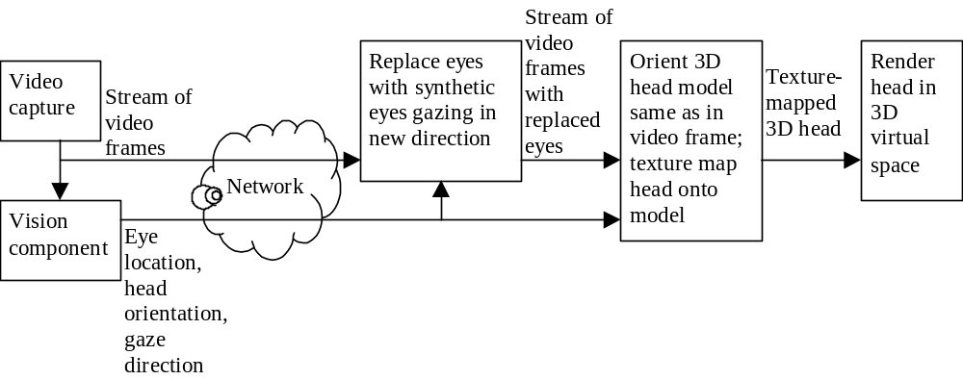
Figure 5: Video sub-system

Rendering
On the receiving end, vision information must be used to extract the head from the video frame, and place it in the virtual 3D space with the gaze corrected. We achieve this in two steps. First, the eyes are replaced with synthetic eyes to aim the gaze. This simulates swiveling the eyes in their sockets. Second, the head pose is adjusted. Note that the eye replacement must take into account the adjustment that will be made to the head pose so that the desired gaze is achieved.
An alternative approach is to use an entirely synthetic head, or avatar, as in [Ohy93, Col00]. Actually, there is a spectrum of possibility, from using the video with no modification at one end, to a fully synthetic avatar at the other. Our approach lies in the middle. The benefit of our approach is that we transmit facial expressions and eye blinks as they appear, while modifying only those aspects of video which affect gaze perception. Achieving a similar effect with an avatar would require a very detailed head model and tracking of additional facial points. As we discuss below, even our modest tracking requirements still require more research, so tracking many points on the face is not currently feasible. A drawback of our approach is that there may be some distortion of the face, which would not occur with detailed head models.
It is possible to achieve arbitrary gaze direction by manipulating the head pose only. However, this means that any time you want the gaze to change the head must be swiveled. Depending on the geometry of the virtual space in respect to the geometry of the actual viewer to the screen, this may lead to a lot of movement by the virtual head that did not occur in the real head. In particular, someone moving their eyes back and forth between two images with no head movement may appear to be shaking their head, as if to indicate “no”, in their virtual representation.
Likewise, gaze could be corrected with eye adjustment only, without any head movement. However, repositioning the pupils may change the expression of the face. Typically when a person looks up or down the top eyelid follows the top of the pupil (See Figure 6(a) and (c)). Without synthesis of the open eye area only the eyelid may appear too low, giving the face an expression of disgust (Figure 6(b)), or too high, making the face appear surprised (Figure 6(d)). Changes in pupil position horizontally have little noticeable effect on facial expression.
Additionally, the head orientation itself conveys a message. A lowered head can indicate distrust or disapproval, while raising the head can convey superiority. How far the eyes are opened and the amount of white showing above and below the pupil are also important to facial expression [Arg88].
Figure 7 illustrates this to some extent, but seeing the motion of the head rising or falling is needed for the full impact. Therefore a correction of the vertical head pose angle between the camera and the images on-screen is required to convey to the viewer the same message that is being implied to their on-screen image.
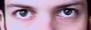 
(a) (b)
 
(c) (d)
Figure 6: As eyes move up and down, so do eyelids. If the system ignores this, it changes facial expressions. (a) Real looking up; (b) Moving eyeballs but not eyelids creates glowering or disgusted expression; (c) Real looking down; (d) Moving eyeballs but not eyelids creates surprised expression.
  
(a) (b) (c)
Figure 7: (a) Head and eyes directed away from viewer-- no gaze awareness and disinterested expression looking at something else; (b) Eyes directed at viewer, head directed away -- creates eye contact, but changes face to glowering expression; (c) Head and eyes directed at the viewer -- creates eye contact and correct facial expression of paying attention to you.

Eye Manipulation
Eye manipulation is composed of two steps: segmentation of the eyes and the rendering of new eyes. The vision component, to be discussed later, provides us with a segmentation of the eyes; that is, it indicates the region of the video frame containing the visible portion of the eyeballs. Computer graphics is then used to render new (synthetic) eyes, focused on the desired point in space.
Computer graphics techniques for eye synthesis are well known, and there are sophisticated techniques that are very realistic. However, we have found a relatively simple technique that is quite effective. We assume the average color of the sclera (“white” of the eye), iris and pupil are known (See Figure 8). If we know the size of the eyeball, the relative size of the iris can be estimated. We fix the radius of the pupil to be a fraction of the iris’s radius. Dilation and contraction of the pupil are not currently modeled. To simplify rendering, the eyes are modeled without curvature. In practice, this is a reasonable approximation because the curvature of the eyes is not really noticeable until the head is significantly oriented away from the viewer (more than 30 degrees from our observations).
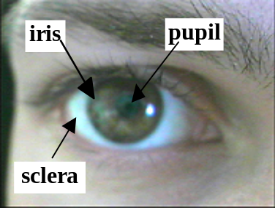
Figure 8 - Diagram of the eye
We begin with a canvas filled with the average color value of the sclera. Two circles are then drawn for the iris and pupil. A circle the color of the pupil is drawn around the edge of the iris, as the iris’s color typically becomes darker around the edges (the limbus). Random noise is added to the iris and the sclera area to simulate texture in the eye. In a very high-resolution system, we may switch to a more elaborate eye model with improved shading, highlights and spectral reflections.
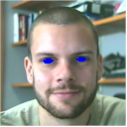
(a) (b)
Figure 9: (a) synthetic eyeball on temporary image (b) video frame with segmented eyeball area filled with blue color.
The eyeball is drawn on the face in two steps. First, the eyeballs are drawn on a temporary image, as shown in Figure 9(a). Second, we use the eye segmentation data to decide for each pixel whether to use the pixel information from the original face image or from the eyeballs image. The simplest method for combining the face image and eyeball image is to use color keying, similar to blue screening. Every pixel that is segmented as an eyeball pixel is colored blue (or whichever color is the color key color) as illustrated in Figure 9(b). The eyeball image can then be blitted onto the face image. For a more refined or realistic look we can blend the edges of the eyeball with the face image using alpha values (See Figure 10).

  (a) |   (b) |   (c)
Figure 10: Original image (center) and two synthesized images with redirected eyeballs combined with original face (a) Looking left; (b) Original image; (c) Looking right
Controlling eye gaze means controlling where the eyes are looking in 3D space. The 3D point that the eyes are looking at is called the gaze point. We want to determine the pupil positions that give the appearance that the eyes are focused on the desired gaze point. The eyes should converge or diverge as the gaze point moves closer or further away from the face. In order to compute the eye pupil positions we need to know (1) the 3D location of the eyeball centers relative to the head model, (2) the radius of the eyeball, and (3) if we have a 3D-head model we need to know its orientation and position in 3D space.
Recall that our model of the eyeball is flat. Thus, we only need to compute the plane on which to render the eye, and the center of the pupil. The plane is chosen to lie in the eye sockets, oriented perpendicular to the direction of gaze. The pupil center is found by intersecting the ray from the gaze point to the eyeball center with the eye plane. Approximating the eyeball as flat will become increasingly inaccurate as the head rotates away from the viewer. This effect, however, is mitigated for three reasons: First, extreme combinations of head orientation and eye gaze (e.g., head facing left and eye gaze sharply to the right) are rare and difficult to modify for other reasons (tracking the eyes in such situations presents significant challenges for vision); thus, our project restricts eye gaze modification to instances when the head is oriented frontally (within ~30 degrees). Second, it is known that we are poor judges of eye gaze when a face is not oriented directly toward us [Arg88, Ant69, Rim76, Nol76]; thus, the errors in approximating extreme poses are unlikely to bother viewers.

Altering Head Pose
So far we have only discussed moving the eyes. Now we move on to rotating the entire head. Our first attempt at rotating the head involved warping the face image using correspondence maps. However, we found many difficulties with this method, including unacceptable distortions [Zit99]. Our present approach changes the head orientation via texture mapping a 3D model. First, a 3D model in the shape of the person’s head is created. The face image from the video frame is then projected onto the model in a process called texture mapping. After the face image is projected onto the model, the model can be rotated to any desired orientation (See Figure 12).
When creating a 3D head model certain details are more important than others. When judging head orientation, two features are most important (from our empirical observations.) First, the eyes must be modeled correctly. While the eyeballs themselves may be flat, the eye socket must be receded into the face. This is important to obtain a realistic look when rotating the head up and down. Second, the nose must be modeled as protruding out of the face.
Other parts of the face that affect judgment of head orientation less – the mouth, forehead, and cheeks – can be modeled by flat or slightly rounded surfaces. The model must be fitted separately for each user to account for differences in facial shape. Since the eye and nose are the most important features, the model is scaled to fit the face based on the geometric relationship of the eyes and nose. The amount the eyes are receded into the face and the amount the nose protrudes from the face are fixed. Once again, we assume the head will not be rotated more than 30 degrees, so the results should be realistic for a reasonable range of facial orientations.
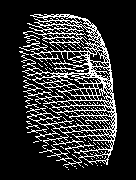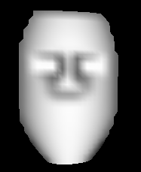
Figure 11: Simple head model used for texture mapping

Texture Mapping a Head Model
In order to texture map a model we need to know three values:
- The position of an anchor point on the 3D model and its location in the face image. We used the center between the nostrils. This point is easy to track since it does not deform significantly when the face rotates or expression changes.
- The orientation of the head in the face image. This can be computed several ways. Two of these techniques will be discussed in the next section.
- The amount to scale the head model to correspond to pixel space. This can be computed while head orientation is being computed.
For each vertex of the head model we need to compute its 2D texture coordinates. The texture coordinates define the location in the face image corresponding to the vertex. If we have the three values described above we can compute the texture coordinates for each vertex with the following steps. We will assume that we are rotating the model about the nose. However, any point may be used.
- For each vertex in the head model, subtract the value of the anchor point.
- Rotate the head model to the same orientation as the head in the face image.
- Scale the X and Y coordinates to correspond to pixel values. This is equivalent to doing an orthographic projection onto the image. An orthographic projection assumes all lines of sight are parallel, unlike the pinhole projection in which the lines of sight intersect at a point.
- Add the 2D pixel location of the nose in the face image.

  (a) |  |   (b)

(c)
  (d) |  |   (e)
Figure 12: (a) Face oriented up left; (b) Face oriented up right; (c) Original image; (d) Face oriented down left; (e) Face oriented down right.

Dealing with Head Shape Changes
When a person is talking or changes expression the 3D shape of the head can change. The most obvious example is the chin moving up and down when a person is talking. If we assume our head model doesn’t change shape this will cause problems. The easiest solution is to extend the wire-frame chin below its normal position. This way when the mouth is opened the chin texture will not slip down to the neck area. When the mouth is closed the neck will appear to be attached to the bottom of the chin, but this should not be noticeable until the head is rotated significantly away from the viewer.
As stated before the eyes and nose are used most when judging head orientation. Fortunately, the eye sockets do not change shape and the shape of the nose rarely deforms. Perhaps humans use the nose and eyes to judge head orientation because these features typically do not change shape. This is to the model's advantage, allowing us to use a static head model to achieve reasonable realism.

Inadvertent Changes of Expression
When rotating a head model away from the orientation of the head in the face image, the features of the face can become deformed. Assuming the texture coordinates were found correctly, any deformations in the face are caused by the face model being incorrect. Many deformations go unnoticed, such as the side of the head being too narrow. Other deformations can actually cause changes of expression in the face. If the curvature of the mouth is incorrect in the head model, the mouth may appear to look either happy or sad when the head model is rotated up and down. The same may occur with the eyebrows, resulting in their appearing too tilted. Since the curvature of the mouth is different for everyone, finding an adequate solution to this problem may require “structure from motion” algorithms from vision, whereby the 3D structure of the face can be computed from a video sequence [Liu00]. Finding which parameters are important to ensure consistent expressions is by itself a difficult task.
If the orientation of the head within the face image is found incorrectly, the same effect can occur. Changes in expression will result when the face image is texture mapped onto the head model incorrectly. This problem is most noticeable with errors in the vertical orientation of the head.

Computer Vision
The vision component must track the head pose (the location of the head and its orientation), segment the eyes, and determine the gaze direction. Computer vision in general is very difficult, and these tasks are no exception. However, there are a number of points that make the problem more tractable: (1) we are looking only for a head, not arbitrary objects, (2) we only need to deal with head poses that allow direct gaze at the screen (if the head is turned further away, it is not looking at anyone on screen, and we can just display the image without any alteration), (3) similarly, we only need to detect gaze in the region of the screen, (4) as mentioned above, humans perceive any gaze around their face as mutual gaze, so we only need to track gaze within relatively broad regions, and (5) humans make errors, such as misjudging gaze direction as the head angle increases, and being misled by the visible head outline to judge head pose, so some of our errors may be no different that what a human would have perceived.
We have tried two different approaches to head pose tracking. The first approach assumes that the camera is mounted below the display, and tracks the user’s nostrils [Zit99]. The orientation of the head is computed based on the deformation of the nostrils. Tracking the position of the nose can be done using standard template matching techniques. If the user gives us the initial position of the nose, a nose template can be created. In each successive video frame we can search within a neighborhood of where the nose was located last to find the best match with the template. When the head changes orientation the shape of the nostril will deform. To predict the deformation of the nostrils, we create a set of nostril templates for a range of head orientations using an affine transformation of the tracking template. These nostril orientation templates can be matched to the current face image to find head orientation. This approach has yielded good results, but can have troubles with large moustaches, or if the user wrinkles her nose.
The second head pose tracker is based on tracking nine small image features on the face, for which the approximate 3D positions relative to the face are assumed to be known (again, structure from motion techniques can provide this information). Each image feature consists of a small rectangular template whose default size occupies 8x8 pixels in the image (the template can be warped according to the expected size and orientation of the face in the image). For each new frame, we search for the minimum sum of pixel-wise absolute differences (SAD) between the template and each sub-rectangle within a restricted region of the live image. The matching starts at a coarse resolution and proceeds to finer resolutions to reduce computation. Once the positions for all nine image features are determined, we then perform a gradient descent in the 6-degree-of-freedom pose space (x, y, z, pitch, roll, yaw) to estimate the final pose. The goal is to minimize the sum of distances between the tracked points and the projected position of those points given a particular pose. Using the last known pose as a starting point, Levenberg-Marquardt optimization [Pre92] achieves this goal within a handful of iterations. The projected positions of the feature points are used as the centers of the search regions for tracking in the next frame (See Figure 13).
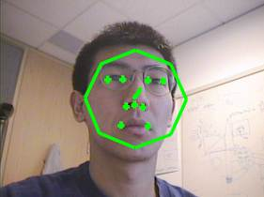
Figure 13: A single frame of face pose tracking. Shown are the nine tracked points on the face, an octagon indicating the plane of the face and a line indicating a normal to the face.
Pose tracking can fail if a large portion of the subject’s face is occluded, or if the subject moves too rapidly. To maintain robustness in these circumstances, we use a fast attentional mechanism [Toy99] to quickly recover tracking. The system detects feature-tracking failure by noticing the large residual error in the SAD computations. It then resorts to skin-color “blob tracking” and head contour tracking to localize the face and reinitialize feature tracking. When the feature trackers find their respective targets, pose tracking continues.
Two approaches have also been tried for eye segmentation. The first is based on a deformable “active contour” [Bla98] that tracks the contour formed by the upper and lower eyelids. Rectangular regions centered on each eye (eye position is determined from head pose information) are first processed to enhance the eye contours (through histogram equalization, smoothing, and ridge detection). Then, the best position for the eyelid contour is estimated by coordinate descent in the space of parameters corresponding to translation in x, translation in y, width, in-plane rotation, scale, and eye openness.
The second approach for eye segmentation is a system for tracking features through a sequence of images called the warp tracker [Kan99]. The warp tracker is initialized with an initial (e.g., canonical) image of the eyes, and a contour around the visible area of the eyes. This image and contour define the source, and segmenting the eyes then amounts to tracking the source contour. For any subsequent target image in which we wish to track the contour, we compute the correspondence map between the source and target images and apply it to the source contour to yield the target contour. To find the correspondence map, we employ an automated multi-resolution lattice deformation technique. Experience shows that the warp tracker performs fairly well on its own, and its hierarchical nature naturally lends itself to being integrated with other tracking algorithms for increased accuracy and robustness. Figure 14 shows some results from the warp tracker. While the early results from warp tracking are promising, it is still to slow (2 frames/second on a Pentium 333) and sometimes produces irregularly shaped contours.
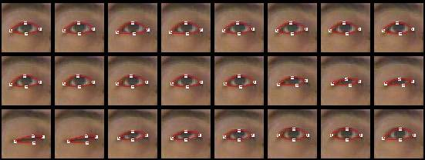
Figure 14: This data set tests the warp tracker’s ability to track changes in shape. The upper left image is the canonical image, for which the user manually initialized the contour. The contours in the rest of the images were then automatically generated with no further user input.

Conclusion And Future Work
The results of our work to date appear promising. Given that accurate vision data can be extracted from each video frame regarding head pose, eye segmentation, and gaze direction, we are able to arbitrarily position and pose the head in a virtual 3D space, and synthesize the eyes with the appropriate gaze direction. The resulting videoconferencing system supports a sense of space and gaze awareness.
Currently, the chief difficulty is in the vision component. Our current methods are still too slow and inaccurate. Work on the warp tracker is ongoing at Carnegie Mellon University, while improvements to the head-tracker are being pursued at Microsoft Research. It is our intention to publicly release our software with a replaceable vision module. This will allow any vision research group to try their approach with our system. While waiting for computer-vision to come up to speed, we may work with infrared-based vision systems in order to push ahead with research on the use of the virtual 3D conferencing environment.
We believe that current videoconferencing systems without gaze awareness present images that are largely lacking in valuable social information. Such video streams quickly become uninteresting and are often ignored. In contrast, it is almost impossible to ignore eye contact. We believe that restoring gaze-awareness to video (along with low-latency, high-quality audio, and easy call set up) will result in a videoconferencing system that finally has a chance to succeed.

Acknowledgements
This work has benefited from insightful conversations with Jim Gray.

References
[Ack87] Acker, Stephen R., and Levitt, Steven R., Designing videoconferencing facilities for improved eye contact, Journal of Broadcasting and Electronic Media, Vol. 31, No. 2, Spring 1987, pp. 181-191.
[Ant69] Anstis, S.M., Mayhew, J.W., and Morley, Tania, The perception of where a face or television 'portrait' is looking, American J. of Psychology, 82(4), 1969, pp. 474-489
[Arg88] Michael Argyle, Bodily Communication, International Universities Press, Madison, Connecticut, 1988.
[Bla98] Blake, A. and Isard, M., Active Contours, Springer-Verlag, 1998.
[Cha72] Chapanis, Alphonse, Ochsman, Robert B., Parrish, Robert N., and Weeks, Gerald D., Studies in Interactive Communication: I. The Effects of Four Communication Modes on the Behaviour of Teams During Cooperative Problem-Solving, Human Factors, 1972, 14(6), pp. 487-509.
[Col00] Colburn, Alex, Cohen, Michael, and Drucker, Steven , The Role of Eye Gaze in Avatar Mediated Conversational Interfaces, submitted to Siggraph 2000.
[Gale91] Gale, Stephen, Adding audio and video to an office environment, Studies in Computer Supported Cooperative Work, J.M. Bowers and S.D. Benford (Eds), Elsevier Science Publishers New York, 1991. Pp. 49-62.
[Gib99] Gibbs, Simon J., Arapis, Constantin, Breiteneder, Christian J., Teleport - Towards immersive copresence, Multimedia Systems, 7:214-221 (1999).
[Hun80] Hunter, Gregory M., Teleconference in Virtual Space, Information 80: Preceeedings of the Eighth World Computer Congress, Tokyo, Oct. 14-17, 1980, Simon Lavington, Ed., Amsterdam-North Holland, pp. 1045-1048.
[Kan99] Kang, Thomas, Gemmell, Jim, and Toyama, Kentaro, A Warp-based Feature Tracker, Microsoft Research Technical Report, MSR-TR-99-80, October, 1999.
[Liu00] Liu, Zicheng, Zhang, Zhengyou, Jacobs, Chuck, and Cohen, Michael, Rapid Modelling of Animated Faces From Video, Microsoft Research Technical Report, MSR-TR-2000-11.
[Mor92] Morii, K., Satoh, T., Tetsutani, N., Kishino, F, A technique of eye-animation generated by CG, and evaluation of eye- contact using eye-animation, Proceedings of the SPIE - The International Society for Optical Engineering, vol.1818, pt.3 1992 18-20 Nov. 1992, Boston, MA, USA, pp.1350-1357
[Nol76] Noll, A.M., Effects of Visible Eye and Head Turn on Perception of Being Looked At, American Journal of Psychology, Vol. 89, No. 4, 1976, pp. 631-644.
[Novick] Novick, David G., Hansen, David G., Ward, Karen, Coordinating turn-taking with gaze. Proceedings of the International Conference on Spoken Language Processing (ICSLP'96), Philadelphia, PA, October, 1996, 3, pp. 188-191.
[Oco97] O'Connaill, Brid, and Whittaker, Steve, Characterizing, Predicting and Measuring Video-Mediated Communication: A Conversational Approach, Video-Mediated Communication, Finn, Sellen, and Wilbur, Ed.'s, Lawrence Erlbaum Associates, Mahwah, NJ, 1997.
[Ohy93] Ohya, J.;Kitamura, Y.;Takemura, H.;Kishino, F.;Terashima, N., Real-time reproduction of 3D human images in virtual space teleconferencing, Virtual Reality Annual International Symposium, 1993., 1993 IEEE; 1993 pp. 408-414
[Oka94] Okada, K., Maeda, F., Ichikawaa, Y., Matsushita, Y., Multiparty videoconferencing at virtual social distance: MAJIC design, Transcending Boundaries, CSCW `94. Proceedings of the Conference on Computer Supported Cooperative Work, Chapel Hill, NC,USA, 1994, pp.385-93.
[Pre92] Press, W.H, Teukolsky, S.A., Vetterling, W.T., and Flannery, B.P., Numerical Recipes in C, Second Edition, Cambridge University Press, 1992, pp. 683-688.
[Rim76] Rime, B, McCusker L, Visual Behaviour In Social-interaction - Validity Of Eye-contact Assessments Under Different Conditions of Observation, British Journal of Psychology, Vol. 67, No. 5, 1976, pp. 507-514.
[Rose95] Rose, D.A.D.; Clarke, P.M., A review of eye-to-eye videoconferencing techniques, BT Technology Journal, Vol. 13, No.4, Oct. 1995, pp.127-31.
[Sel95] Sellen, Abigail, Remote Conversations: The effects of mediating talk with technology, J. Human-Computer Interaction, 1995, Vol. 10, pp. 401-444.
[Sto69] Stokes, R.R., Human Factors and Appearance Design Considerations of the Mod II PICTUREPHONE Station Set, IEEE Trans. Communication Technology, Vol. COM-17, No. 2, April 1969.
[Suw97] Suwita, A.; Bocker, M.; Muhlbach, L.; Runde, D., Overcoming human factors deficiencies of videocommunications systems by means of advanced image technologies, Displays, Vol. 17, No.2, April 1997, pp.75-88.
[Toy99] Toyama, K., and Hager, G., Incremental Focus of Attention for Robust Vision-Based Tracking, International J. of Computer Vision, Vol. 35, No. 1, 1999, pp. 45-63.
[Tro98] Troje, N.F., Siebeck, U, Illumination-induced apparent shift in orientation of human heads, Perception, Vol. 27, No. 6, 1998, pp. 671-680.
[Ver99] Vertegaal, Roel, The GAZE groupware system: mediating joint attention in multiparty communication and collaboration, Proceeding of the CHI 99 conference on Human factors in computing systems: the CHI is the limit, pp. 294-301.
[Zit99] Zitnick, C. Lawrence, Gemmell, Jim, and Toyama, Kentaro, Manipulation of Video Eye Gaze and Head Orientation for Video Teleconferencing, Microsoft Research Technical Report, MSR-TR-99-46, June 1999.

