Rural Kiosks in India

July 2004

Kentaro Toyama
Karishma Kiri
Maithreyi Lakshmi Ratan
Anil Nileshwar
Rama Vedashree
Rafael Fernandez MacGregor
Microsoft

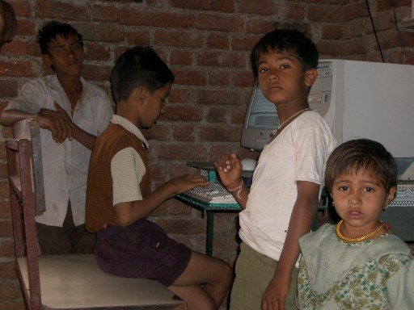
Figure 1. A 12-year-old typing student (and friends) at an n-Logue kiosk near Pabal, Maharashtra.

1 Introduction 3
2 Points of Entry 3
3 Usage Scenarios and Benefits 4
4 Needs and Challenges 6
4.1 Operational Challenges 6
4.2 Technology Needs 7
5 Other Salient Characteristics 8
6 Alternatives to PC-Based Kiosks 9

Introduction
By some estimates, there are as many as 150 rural PC-kiosk projects across India, many of which already have, or are planning, thousands of installments. Most of these projects were started within the last five years, riding on India’s booming IT industry. Reflecting the nation’s diversity, these initiatives differ in goals, models, operating paradigms, and geographic distribution. Every sector is involved – large enterprise, entrepreneurs, universities, government, and NGOs – with motives ranging from turning a commercial profit, to driving socio-economic growth, to streamlining government bureaucracy.

Rural kiosks could provide the first computing experience for as much as 700 million people in India. The sheer number of people who fall into this category is difficult to ignore. Indeed, the recent Indian election results are an indication of this segment’s frustration and provide a loud reminder of its collective influence. In this political climate, rural technology initiatives will become even more important.

Although the average member of this demographic lives on less than a dollar a day, even conservative estimates today suggest that rural India has an aggregate discretionary income of US$ 2 billion per year. On the one hand, they struggle to obtain basics such as drinking water, food, shelter, electricity, and proper healthcare. On the other hand, they will spend what little they have to purchase goods and services beyond these necessities that promise a better life. One of the questions raised in this paper is whether computing technology can play a key role in the socio-economic development of rural areas.

Early evidence indicates that rural kiosks help impoverished villagers improve their standard of living by expanding livelihood options and empowering them with information, tools, goods, and services (such as education and healthcare). The true challenge is in finding ways to deliver this benefit broadly and consistently, while making kiosk projects economically sustainable in the long term. As would be expected when the world’s most advanced technologies are dropped in the middle of pre-industrial farming communities, great innovation is required at the interface, both technically and in terms of sustainable business models.

This document provides an overview of rural kiosks in India, drawing from information we have gathered from the media, Internet web sites, academic studies, interviews with NGOs, and a number of personal visits to project headquarters and actual kiosks in rural villages. Most of the information presented in this document was not collected through formal studies, and so it should not be taken as verified truth. Nevertheless, our hope is that the contents provide an accurate, if impressionistic, view of rural kiosks in India.

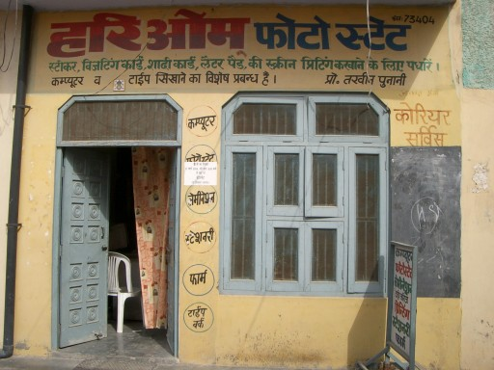 | 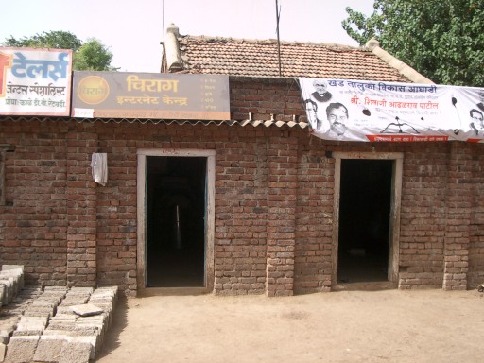 | 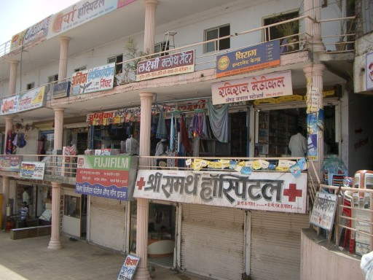
Figure 2. Entryways of rural kiosks in Sirsa (Drishtee), Retaudi (n-Logue), and Shikrapur (n-Logue).

Points of Entry

Participants in the rural kiosk space enter with different agendas. One way to segment kiosk projects is by looking at who and why – who started the project and for what purpose. Along these lines, we can broadly split kiosk projects into commercial initiatives run by large enterprise, community-oriented entrepreneurial projects, and government-led initiatives.

Commercial Initiatives: Large enterprises see immediate or future opportunities in rural markets. Naturally, increasing the corporate bottom line is a primary driver. Kiosk projects may also raise a corporation’s public profile, as they tend to generate positive press, especially if the projects demonstrate lasting value to the constituent villagers. One prominent example of a commercial initiative is ITC’s e-Choupal, which supplies market information through village kiosks to entice farmers to sell directly to ITC. Similarly, EID-Parry in Tamil Nadu supplies sugarcane farmers with agricultural information. Other examples include ICICI’s rural banking and micro loan services and Hindustan Lever Limited’s e-Shakti online store for rural markets.

Backed by large corporations, these projects tend to be independent, self-reliant, and interested in extending their core businesses. Although, they are not driven primarily by a desire to spread computing technology to villages, many observers believe that these projects will endure in the long term, because their business case is soundly established.

Entrepreneurial Initiatives: Many kiosk projects are run by community entrepreneurs, often in close partnership with NGOs and non-profit foundations. Although it may seem strange to lump entrepreneurs and NGOs in one category, they are actually driven by similar goals with respect to kiosks: The entrepreneurs are eager to service their communities’ needs while making a profit, and the NGOs are intent on having social impact that is economically sustainable and scalable over time. Drishtee for example, spun-off from an IT services company to better serve its goal of “connecting India village by village.” N-Logue, incubated by a group including university faculty and entrepreneurs, has a similar vision. TARAhaat is a start-up initiated by a non-profit organization that aims to help develop rural communities via Internet-based services.

Most of these projects are experimenting with different services and expansion plans. One unique characteristic of this group is that they see technology as a key component of their mission. They want to see the connected PC playing a key role in empowering villages. Thus, creative uses of the kiosk PC are encouraged, beyond any one single application.

Government Initiatives: National and state governments have been increasingly focused on introducing IT to rural areas. They are driven by a desire to build IT capacity amongst their citizens, to stimulate economic growth in villages, and to streamline bureaucratic processes. Examples include Kerala’s Akshaya project which seeks to make 100% of the state’s households computer literate, and Bhoomi, in Karnataka state that makes citizen land records accessible online and through kiosks.

The government, of course, supplies much of the seed investment for these projects, and in many cases also subsidizes operating costs. Computerized government services seem likely to endure, especially where they replace older bureaucratic processes or are tied to fundamental government-to-citizen (G2C) needs, such as with land records or education.

Usage Scenarios and Benefits
In industrialized nations, the connected PC offers convenient access to information and services that already exist offline. In underserved communities, this benefit is more pronounced and goes far beyond mere convenience. In many cases, a kiosk brings to the villager information that once was practically unavailable, and services that took days of costly travel are now within biking distance. One study showed that each kiosk typically saves a village $15,000 annually in costs of trips into town and lost wages.

So, the value of a connected PC in a village can be immense. Enumerated below are some of the more common usage scenarios. Although any given kiosk is unlikely to provide all of these services, none are able to survive without offering at least a few:

- E-Government: National and state governments are both eager to computerize their bureaucracies where possible, and entrepreneurs, such as Drishtee, have entered the market to aid the government in making services widely available. Applications range from filling out forms, applying for licenses and birth certificates, filing petitions and grievances, printing land records (used frequently in official business), and so forth.
- Education: In most cases today, “education” at rural kiosks is about computer-skills training. Those with even just a basic familiarity with word processors and spreadsheets become eligible for relatively well-paying data-entry jobs. In some kiosks, typing lessons were also a source of income. In a few cases, a kiosk offers tutoring services or distance learning for academic fundamentals. Results of school entrance exams can be accessed at some kiosks – this service is in great demand during certain times of year.
- Communication: Projects such as n-Logue offer communication services that leverage their unique connectivity solution. These wireless connectivity solutions also provide some villages with their only phone. For younger customers who are curious about computers and life elsewhere, e-mail and chat become instant favorites. Less popular, but not unheard of is video conferencing. In some regions, VoIP is growing in popularity, especially for those who have relatives overseas.
- Agriculture Services: Many kiosks are intended to provide accurate and relevant information to the working villager. Market prices for agricultural products, discussion boards for farmers, and remote consultation with experts are common applications. Users can be suspicious of information delivered through kiosks at first, but will issue test questions to the system to verify its usefulness.
- Entertainment: Video games are a driving application at a few kiosks, mostly among pre-teen kids. Photo services – renting digital cameras and selling prints – are very popular in kiosks that have the capability. In certain areas, listening to music, receiving sports updates or watching videos is common. However, at one kiosk we visited, the kiosk operator preferred not to allow movie watching, as it hogged kiosk usage.
- Community/Religion: Job searches on the Internet are not uncommon. Astrology is taken seriously in many communities, and believers will pay for computer-generated horoscopes. One kiosk operator was able to post a profit solely from sales of astrological charts. Matchmaking services are also quite popular – often these services are utilized by the family of the prospective brides and grooms.
- Professional Services: Health services (telemedicine) can be provided over the Internet, either through email or video-conferencing. Also, banks and insurance companies have begun to tap into the large rural market, by offering basic services online or at nearby kiosks.

Beyond the obvious surface value of these applications, rural kiosks also contribute immediate and lasting gains to their local economies. For one thing, the kiosk itself often provides a new livelihood for the kiosk operator and brings with it both income and respect. Most operators express unqualified satisfaction with their kiosks – even when struggling to break even. Another boost comes from computer-skills education and typing lessons which can make a student eligible for data-entry jobs that pay relatively well. And, timely access to fair market prices can consistently bring as much as several percentage points of additional profit to farmers for their produce.

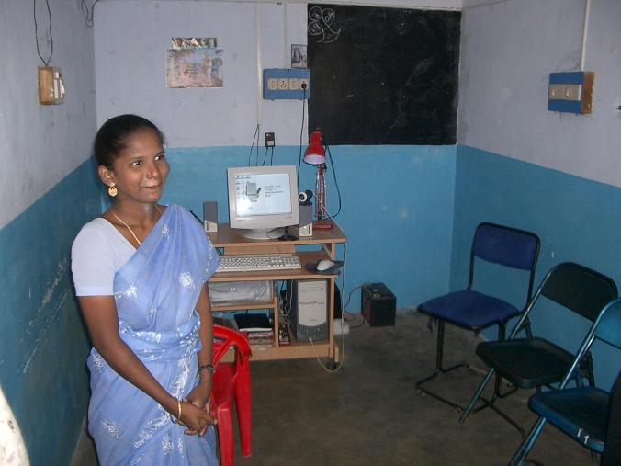 | 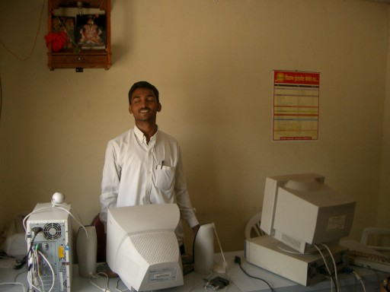 | 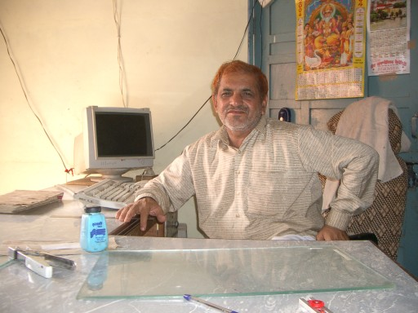
Figure 3. Some proud kiosk operators in Tiruvallur (left, n-Logue), Jategao (middle; n-Logue), and Ding Mandi (right; Drishtee).

Lastly, kiosks have some less quantifiable, but socially significant effects. In many cases, a kiosk not only brings the first PC to a village, but the first tangible presence of state government or local enterprise. The kiosk can therefore help to build trust between villagers and the organization implementing the kiosks. Within the village itself, kiosks can contribute to social cohesion. Often as a result of the entrepreneurial efforts of the kiosk operators, or the nature of kiosk-related activities, groups of villagers are brought together, quickly establishing the kiosk itself as a social center. A final example is increased opportunity for women. Many kiosk operators are women, and for them, the kiosk represents an empowering livelihood outside of traditional village roles.

Needs and Challenges
Given their placement in rural locations among impoverished populations, it is not surprising that rural kiosk projects face similar challenges, even amidst the diversity in geography, culture, and language. In project after project, the same obstacles arise.

Operational Challenges
Most projects face the same operational hurdles: first, when setting up kiosks, and later in trying to generate enough revenue to sustain themselves:

- Start-up costs are high. The minimum cost for a single kiosk installation is typically around $1000 – the yearly income of a rural villager – including both hardware and software. Most often, this investment will be made by the village kiosk operators themselves, the majority of whom will be required take out a loan (some will take advantage of government loan programs designed for the poor).
- Infrastructural obstacles are severe. Many villages only have power for a few hours a day and telephone land lines extend to at most to 4% of the rural population. These problems are most easily handled with hardware solutions, as described in Section 4.2. These solutions, however, add to the total start-up cost for a kiosk (up to $6000) and it remains unclear whether this cost can be made up in the long run.
- Kiosks are critically dependent on good kiosk operators. At the kiosks themselves, the single most reliable predictor of revenue appears to be the entrepreneurial capacity of the kiosk operator. So, successful kiosk projects expend a lot of resources identifying potential operators and training them. Preferred traits include a secondary school education, experience with a business, marketing savvy, middle-to-high social standing in the village, and a family – children often are quickest to pick up new technology, and siblings and parents can help run shop. The better training programs run for at least several sessions and teach skills ranging from mouse usage to basic bookkeeping and marketing.
- Kiosks are sensitive to location and population density. Greater foot traffic leads to greater returns. For two of the more profitable kiosks we visited, one was located in a government office complex, and the other was in a successful mom-and-pop pharmacy, located right on the town’s main avenue. Some projects will also specify conditions for a village’s eligibility for a kiosk: a minimum population (e.g., 5000), greater or lesser accessibility from cities, and relevance to the project leader’s core business (e.g., crop type).
- There is no single killer app. Different applications make different kiosks successful. There is no one class of applications that works at all locations, and the primary generator of revenue at kiosks differs from village to village. Adaptation to local needs is necessary if a kiosk project hopes to endure. Diversified offerings also help – gradually, rural kiosks appear to be converging to offering a smorgasbord of applications.

 | 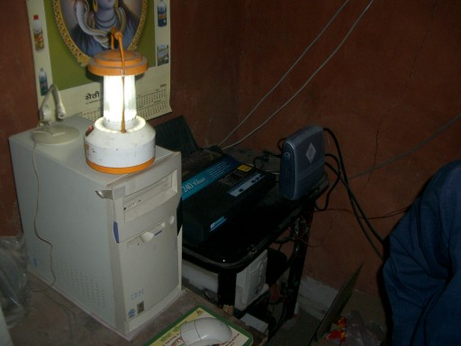 | 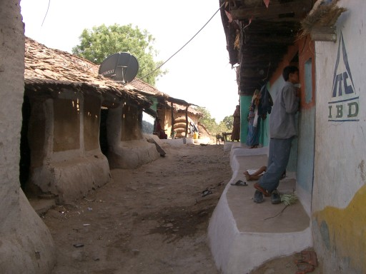
Figure 4. Kiosk hardware: n-Logue wireless access tower (left; Tirumvallur), solar-charged lamp and UPS (middle), VSAT satellite dish for connectivity (right; ITC e-Choupal, Kodia).

Technology Needs
Rural kiosks, of course, demand considerable innovations in technology. Indeed, some kiosk projects claim that their primary contribution is itself technological (as with n-Logue’s connectivity solution). The standard PC set up that works in first-world white-collar offices works surprisingly well in rural environments, but there are still a few additional technical problems that should be addressed. In hardware, for example, there are challenges in the following:

- Power management: Batteries, solar power, UPS, and generators offer more reliable power, but further innovation in low-power systems and power management is valuable.
- Connectivity: Poor connectivity is handled through VSAT satellite dishes or specially developed wireless access solutions (e.g., n-Logue’s corDECT). Mobile wireless, WiFi, and WiMAX technologies are likely to become more important as time goes on.
- Rugged hardware: Rural PCs are often located in dusty rooms with poor ventilation and no air conditioning. Hardware that is robust to these conditions and to extremes of weather is desirable. Inexpensive solutions in common use against dust include vinyl covers and plastic bags wrapped over equipment.

Most kiosk operators consistently mention two features they would like to see:

- Language localization: This is a frequently asked-for feature. Some percentage of villagers can read in their local language, but are less than comfortable with English. Even where the kiosk operator is able to understand English, he or she will request language-localized versions of software for the sake of other villagers or for his/her own ease of use.
- UIs for the illiterate and semi-literate: Many kiosk users want simplified UIs that do not require fluent literacy. One kiosk operator, for example, suggested that the PC could say words aloud when mousing over text.

Other features that could help rural kiosks include the following:

- Automated PC management: Because kiosk operators have minimal training with PC management, there is a need for security features, system-lockdown capability, and portable profile management. Remote management might also be a possibility, but poor connectivity must be taken into account.
- Disconnected or very-low-bandwidth operation: Since connectivity can be unreliable, features that offer nearly seamless operation bridging connected and disconnected states would appear to be useful (e.g., automatic download of data when connected).
- Transliteration and translation software, multilingual systems: India is extremely diverse in the number of languages spoken, and no single language is a nationwide lingua franca. Thus, systems which allow communication across language barriers and allow easy switching between languages seem useful.
- Speech-based UIs and alternative input devices (e.g., pen): Again, these would address issues with literacy and unfamiliarity with mouse and keyboard.

These latter features are those that we, as sophisticated computer users, imagine would be useful given our observations. But, rural villagers exhibit a lot of patience with their software. Most seemed quite happy to learn the sequence of steps required to engage with the PC – for them, any inconvenience due to deficiencies in power, connectivity, or usability, pales in comparison to the alternatives, which might require lengthy trips into the city or tortuous dealings with absurd bureaucracies.

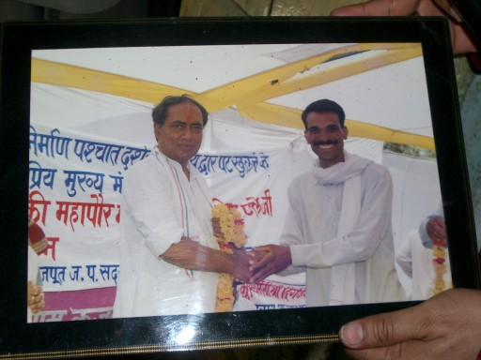 | 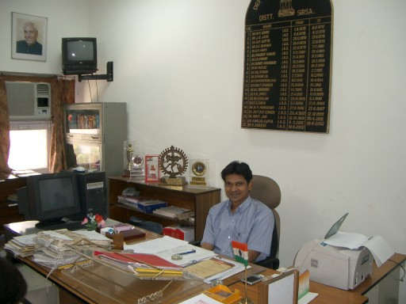
Figure 5. Government is often involved. Photo of kiosk operator with Madhya Pradesh Chief Minister (left; e-Choupal, Kodia), and Sirsa Deputy Commissioner, a strong proponent of information and communication technologies for rural villages, with PC and PDA.

Other Salient Characteristics
Beyond usage scenarios and challenges, there are a few additional traits that most kiosk projects share.

- All projects have socio-economic development of rural regions as a goal. This motive extends even to the front lines – one kiosk operator applied his profits toward a community hand pump. On the kiosk side, target customers are motivated by a desire to improve their living conditions, in contrast to Internet café-goers who mainly seek entertainment or social interaction.
- Government is frequently involved. Many kiosk projects start either as government initiatives or as entrepreneurial projects to bring government services to rural areas. Even projects that begin as purely commercial ventures often end up partnering with government. Especially as a project scales to hundreds or thousands of villages, cooperation of government is necessary and can expedite expansion.
- The leading kiosk projects develop their own content as web-based services. This strategy allows centralization of development effort, easy language localization, and reliable transaction monitoring.
- Business models are still being tested. Most projects are wrestling with different approaches and offerings; breaking even as a business is not trivial. On the other hand, if kiosks succeed in achieving economic growth for rural communities, that would change the business landscape they operate in, possibly weakening their own raison d'être. Whatever the case, the future of rural kiosks is difficult to predict.

One thing that seems certain is that kiosks will probably evolve rapidly and dramatically before reaching equilibrium. Many projects will fail. A few will survive – but not necessarily in their current form.

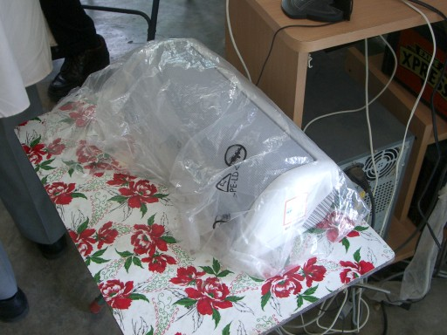 | 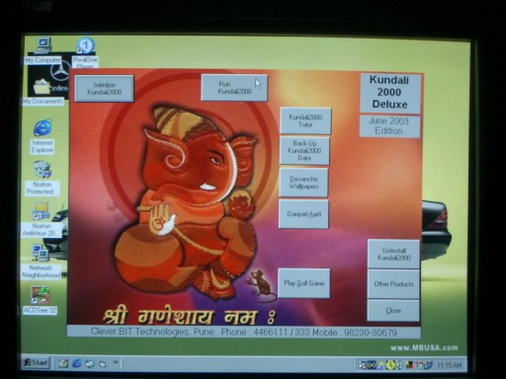 | 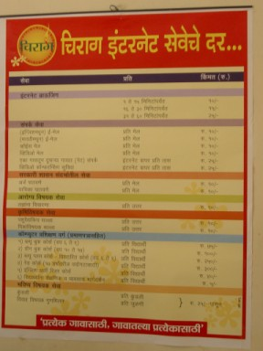
Figure 6. Left, a printer covered in plastic to protect from dust. Middle, language-localized astrology software. Right, a price chart for kiosk services.

Alternatives to PC-Based Kiosks
Mobile phones seem the most likely candidate to serve as a viable alternative to PC-based kiosks. In emerging markets worldwide, mobile phones have spread with unforeseen speed. Leap-frogging landline infrastructure, mobile phones are becoming common even among the poor. Providing connectivity at reasonable costs and increasingly greater processing power, they could easily supplant PCs as the gateway to information and electronic services. In particular, of the seven classes of kiosk applications called out in Section 3, only one or two are dependent on the PC as such.

It is also possible that the most compelling scenarios will be hybrid experiences, where a shared-access kiosk provides a full Internet experience occasionally, and pre-paid mobile phones provide a shallow experience continuously. Neither mobile providers nor computing firms have emerged with such a solution thus far.

Aside from mobile phones, other hardware that could bring computing to rural populations include TV set-top boxes and other low-cost form factors that offer a feature-poor computing experience. Both of these approaches dramatically reduce the cost of hardware, which is the one input cost that has a hard lower bound. Such devices could be paired with web services that provide much of the frequent-use functionality in PC kiosks.


Figure 7. Children from Kodia village, near Bhopal, expressing curiosity in a digital camera.

Based on a 2004 study by Digital Partners and Intel that polled 30 kiosks in three states with village populations averaging 5000 residents.

