The Microsoft Multiperson Location Survey

John Krumm and Eric Horvitz
Adaptive Systems and Interaction Group
Microsoft Research
Microsoft Corporation
One Microsoft Way
Redmond, WA USA

MSR-TR-2005-103
Last Revision: August 2005
 | 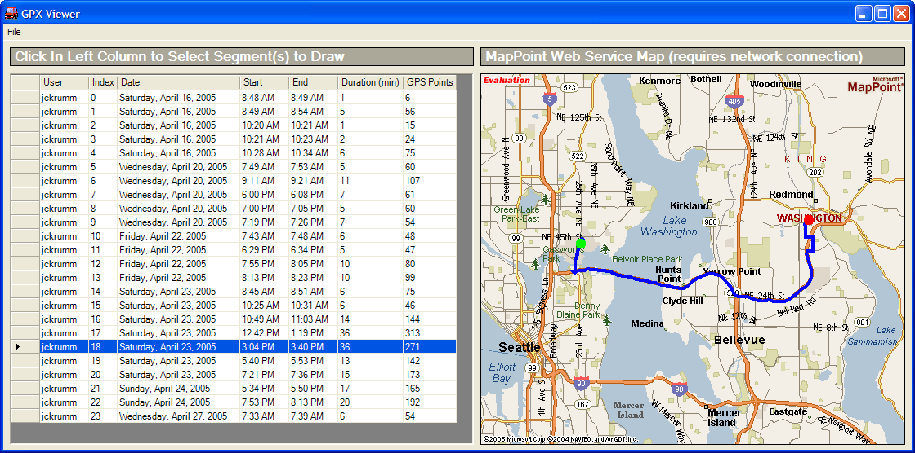
Figure 1: On the left is the GPS receiver that we loaned to volunteers to collect driving data. On the right is the viewing program that volunteers were given to reveiw their tracks.

Abstract
The Microsoft Multiperson Location Survey (MSMLS) is an ongoing research project aimed at surveying the travel patterns of regular people. We loan to our volunteer subjects a GPS receiver capable of measuring and storing time-stamped (latitude, longitude) data. Nominally, we expect our subjects to leave the GPS in their car for about two weeks, during which time the GPS will record everywhere the car goes. When the subject returns the GPS, we upload the stored data to our server. With this data we are pursuing research projects for generating efficient driving directions and predicting a driver’s destination. This evolving technical report describes the project and the data gathered so far.

Introduction
The Microsoft Multiperson Location Survey (MSMLS) is an ongoing project aimed at gathering data about where people go in their daily lives. Volunteer subjects for our survey are loaned one of 40 Garmin Geko 201 GPS receivers (Figure 1) for nominally two weeks. The default use of the receiver is to power it from the cigarette lighter in the subject’s vehicle, with the receiver resting on the dashboard or some place with a clear view of the sky for GPS satellite reception.
75% male | Average age about 36
71% with domestic partner | 48% with children
Figure 2: Demographics of the 118 subjects in our GPS location study.

Data Collection
Our GPS receivers are capable of recording up to 10,000 time-stamped (latitude, longitude, altitude) triples. The Geko 201 can be programmed to record at regular intervals in time or distance. We used a third mode that adaptively records more points when the receiver is accelerating or turning, presumably by thresholding on the deviation between the measured point and the receiver’s internally extrapolated estimate. This mode offers five resolution settings varying from “highest” to “lowest”. We chose the “highest” setting. For the approximately 480,000 points we recorded, the median distance between the points was 62.0 meters, and the median time between points was 6.0 seconds. Our GPS receiver uses the wide area augmentation system (WAAS), whose RMS error has been measured as 1.13 meters[1].

Demographics and Trip Statistics
Figure 3: Histograms of trip times and trips per day. The mean trip time is 14.4 minutes, and the mean number of trips per day is 3.3.

We solicited volunteer subjects primarily from Microsoft Research, but some volunteers were other Microsoft employees and spouses. The demographics of the subjects are shown in Figure 2. Overall, of the 118 subjects, 75% were male, 71% had a domestic partner, 48% had children, and the average age was about 36.
For the purpose of determining trip destinations, we segmented each subject’s data into discrete trips. After downloading from the GPS into our database, each subject’s raw data consisted of a sequence of time-stamped (latitude, longitude) coordinates. (We ignored altitude.) We split these sequences into discrete trips by looking for places in the sequence that met either of the following criteria:
- Gap of at least five minutes – This indicates that the GPS was not moving and, because of its adaptive recording mode, not recording new points. Such a gap can also come from vehicles whose cigarette lighter turns off with the car, which would turn off the cigarette lighter-powered GPS.
- At least five minutes of speeds below two miles per hour – This accounts for the fact that, even when parked, GPS noise can make it appear that the vehicle is moving slightly. Five minutes or more of this extremely slow apparent movement is considered a split between trips.
Segmentation resulted in a total of 4300 discrete trips. To check the plausibility of our segmentation scheme, we computed statistics about the trips to see if the results were reasonable. One statistic is the average temporal length of each trip, which was 14.4 minutes. A histogram of trip times is shown in Figure 3. Lacking any other source of trip length statistics, this result appears reasonable. Another statistic is the average number of trips per day, which we computed as 3.3, also a reasonable number. A histogram of the number of trips per day is shown in Figure 3.
References

1. Coyne, P.I., S.J. Casey, and G.A. Milliken, Comparison of Differentially Corrected GPS Sources for Support of Site-Specific Management in Agriculture. 2003, Kansas State University Agricultural Experiment Station and Cooperative Extension Service.

