Fast Soft Shadows on Height Fields
via Multi-Resolution Image Processing
John Snyder, Derek Nowrouzezahrai
Microsoft Research
Initial draft: 1/30/2008
Figure 1: Soft shadows enhance shape perception.

Introduction
Soft shadows provide cues critical for perceiving shape. As shown in Figure 1, without shadows it is impossible to determine height and proximity relationships (How high off the ground did this character jump? How tall are these pyramidal features relative to each other?) or even whether a given feature indents or protrudes. Soft shadows get sharper and darker as the distance between the shadow caster and receiver decreases, and so provide an excellent proximity cue. They also clearly disambiguate indentations from protrusions. Conversely, ignoring shadows makes shapes appear to be glowing oddly, as in the bust of Max Planck in the figure. Because the human visual system has evolved in the physical world, lack of physical shadowing effects leads to misinterpretation of images of the geometry.
Current graphics hardware does support hard shadows from a point light source, e.g. by using the shadow buffer [Williams78]. Hard shadows have problems of their own. Unlike soft shadows, they don’t sharpen closer to contact. Unlit areas are completely black and thus obscured. Visually prominent edges are introduced having only a secondary relationship to the original geometry. To examine an object closely, one places it under a big light source, not across the room from a candle. In the same way, synthesizing soft shadows best exploits the human visual system to perceive the geometric structure of data.
Existing methods for rendering soft shadows are too compute-intensive and impractical for interactive evaluation. Most are based on ray tracing, in which rays in all directions are shot from each receiver point in order to query whether an object intervenes and so shadows the receiver before the ray hits the sky or other light source. Soft shadows are based on large area light sources which require the sampling of hundreds or thousands of different directions, at millions of receiver points. The computation takes on the order of minutes on a single processor CPU for height fields of moderate resolution (e.g., 512×512). This is unacceptable when users want immediate feedback or are visualizing dynamic data. Alternately, one can accumulate over many hard shadow renderings of the scene, one for each of a set of points distributed over the area light source [Segal92]. When the lights get large, this method requires too many passes to be practical for real-time rendering. It also relies on fast graphics rasterization hardware and is unsuitable for CPU implementations.
We present a new method for interactively generating soft shadows on height fields. Direct applications include data visualization and plotting of scalar, bivariate functions, such as in Excel. Realistic rendering of dynamic or very large terrains, needed by flight simulators and outdoor 3D games, is another application. We also believe that our method may be extended to more general geometry including triangle meshes, perhaps by converting them to a height map via z-buffer rasterization [Shanmugam07]. This would extend the method’s usefulness to solve challenging problems in many other real-time computer graphics applications, such as realistic rendering of synthetic clothing, which is not a simple height field.
Our method can be implemented entirely on the CPU to achieve interactive performance. It can also be mapped to fast graphics GPUs to improve the performance further.
Our work has two main contributions. We show how to compute self-shadowing over the height field quickly, by substantially reducing the number of samples needed. We accomplish this using a multi-resolution pyramid which increasingly prefilters the height geometry as the distance from shadow caster to receiver increases. Though multi-resolution pyramids have long been used in computer graphics and image processing applications [Burt81][Williams83], we apply them for the first time to the problem of generating soft shadows on height fields, using the concept of a multi-scale derivative. Soft shadows are generated by computing a multi-scale blocking angle for each of a series of azimuthal direction samples and converting each consecutive pair to a visibility wedge represented using spherical harmonics (SH). By restricting visibility to a partial azimuthal swath smaller than $2π$, we get sharper shadows than can be obtained with complete swaths using the same SH order.

Previous Work
Ambient occlusion [Bunnell05][Kontkanen05][Oat07][Shanmugam07] produces maximally soft shadows based on the average visibility direction and its total subtended angle. Our method generalized ambient occlusion in that it computes true low-frequency blocker visibility (in terms of 16D spherical harmonic vectors) rather than using a simple cone model. Our shadows have a much clearer response to lighting directionality (see [Ren06] for image comparisons).
Precomputed radiance transfer (PRT) [Sloan02] generates real-time soft shadows and allows real-time manipulation of area lighting, represented using low-order spherical harmonics (SH). Unfortunately, it requires costly precomputation involving ray tracing over each static object and so is unsuitable for dynamic geometry or immediate feedback.
Spherical harmonic exponentiation (SHEXP) [Ren06][Sloan07] allows soft shadows on dynamic geometry, but is specialized for articulated characters, which are approximated as a small set of spheres. The sphere approximation is not appropriate for detailed self-shadowing. What’s more, it is generated by an expensive precomputation on the rest pose of the character to optimally distribute the spheres within its solid interior.

Basic Idea
An azimuthal direction is a 2D direction in the plane of the height field. To compute shadows on the height field in a given azimuthal direction, we need to find the maximum blocking angle in that direction. This requires sampling the height difference between a given receiver point on the height field (i.e., point to be shaded, requiring a calculation of how much it is shadowed) and many shadow caster points on the height field at different distances away from the receiver in the given azimuthal direction. Sampling at many distances, at each of many receiver points, yields a slow computation. Without any prefiltering or a priori knowledge of the height field geometry, the height field variation should be sampled using a fixed number of samples per unit distance. As the (exponential) distance scale to the receiver point increases, exponentially more caster points must be sampled. The problem is exacerbated if we sample over an azimuthal swath rather than in a single direction, because the sampling pattern becomes 2D instead of 1D.
We can reduce aliasing and thus the need for so many samples with a multi-resolution pyramid computed over the height field. We use the pyramid to sample height differences between a receiver point and neighboring caster points at the same pyramid level, using the concept of a multi-scale directional derivative. This approximates the tangent of the blocking angle as a function of distance from the receiver. To sample these height differences at distances far from the receiver point, we use a coarse pyramid level to prefilter the height variations. Closer to the receiver point, we use finer pyramid levels, giving us a more exact approximation of the height difference that is sampled more densely. The multi-resolution pyramid essentially determines a sampling density which increases only logarithmically with increasing distance (i.e., linearly with increasing distance scale) to the receiver, and applies proper prefiltering to height variations at large distances.
At a given receiver point, once we have computed the blocking angle at every pyramid level, we reconstruct a smooth, continuous function of log distance using bspline interpolation and then find the maximum of this function. Finally, we convert a series of these maximum horizon elevation angles, sampled at various azimuthal directions, to a visibility vector using the spherical harmonic (SH) basis. Essentially, we provide a fast way of computing a horizon map [Max88] using simple, multi-resolution image processing rather than slow ray tracing. We also render this horizon map by converting successive pairs of horizon elevation angles into a spherical harmonic visibility wedge that lends itself to rendering soft shadows from large area light sources. The visibility wedge’s basis functions are based on a linear transition in blocking angle from a specified value at one end of its azimuthal extent to another specified value at the other.
If we know the light is not coming from all around the height field, but instead is azimuthally restricted to a partial swath, we can obtain sharper shadows (see Figure 10). Our visibility wedge basis functions are represented in terms of SH but are precomputed by dividing the partial swath azimuthally into a number of smaller angular intervals. If we compute visibility over the complete horizon, then visibility information outside this partial swath will smear out due to SH projection and still have a contribution inside it. By using a partial swath, we ensure only visibility inside the swath is considered and can affect shading. It’s as though we had a light whose extent was truly restricted to this swath and was exactly 0 everywhere outside it, even though no such function bandlimited to low SH orders is capable of this. Said another way, we essentially make use of prior information about the lighting – its azimuthal extent – that can’t be reconstructed merely from its SH projection in order to obtain sharper shadows.
Two technical points in the implementation should also be emphasized. In dealing with multi-resolution image processing, we need not limit ourselves to the standard power of 2 pyramid – pyramids with finer steps between levels tend to work better for typical height fields. We also need to apply a smooth reconstruction when sampling height differences, such as bicubic bspline interpolation, since the soft shadows we target also vary smoothly over the height field. Bilinear interpolation is insufficient and leads to artifacts in the shadows (see Figure 8). Note that such reconstruction is not supported natively using texture mapping on current GPUs, but it can be efficiently implemented using four (bilinear) texture map accesses [Sigg05].

Height Field Visibility: Mathematical Fundamentals
Figure 2: Blocking angle at receiver point x as a function of azimuthal direction φ.

We denote 2D points as $x=\left(x,y\right).$ A height field (scalar function of two variables) is denoted $f\left(x\right)=f\left(x,y\right)$. It is tabulated with sampling resolution $n_{x}×n_{y}= n×\left(α n\right)$, where α is the aspect ratio. The sample spacing is denoted $∆ =1/n$.
The height field determines a 3D surface $z=f(x)$, with 3D points $p=\left(x,y,f(x,y)\right)$, which we would like to shade with soft shadows. To do this, at every point $x$ we need to compute the visibility in all azimuthal directions, parameterized by $(\cos{φ,\sin{ φ)}}$, $φ∈[0,2π]$. (Note: azimuthal directions are directions across the 2D plane of the height field.)
Visibility can be represented in terms of the maximum elevation angle the height field’s horizon reaches in the $φ$ azimuthal direction, as seen from $p$. We call this the blocking (elevation) angle at $x$ (or $p$) in the azimuthal direction $φ$, and denote it $ω\left(x,φ\right)$. At elevations below this blocking angle, the direction is blocked by the height field and can’t see the sky (see Figure 2). The blocking angle is defined via
$$ω\left(x,φ\right)=\max_{t∈(0,∞)}{\tan^{-1}\left(\frac{f\left(x+t\cos{φ}, y+t\sin{φ}\right)-f(x,y)}{t}\right)} ,$$
where t represents azimuthal distance along the direction $φ$ away from the receiver point x. The blocking angle is 0 if the height field does not occlude itself at all (i.e., at $p$ in direction $φ$, one sees the entire sky all the way down to “sea level”) and varies up to $π/2$ as the height field increasingly occludes itself. We make the assumption that the blocking angle is always positive; i.e., $ω\left(x,φ\right)≥0$. This is true for height fields of bounded height but unbounded extent, and roughly true for large or relatively flat height fields. It can be seen that (1) contains an expression very like a numerical directional derivative of f, which forms the tangent of the blocking angle as a function of distance t. This observation prompts our prefiltering approximation.
To approximate (1) and accelerate its evaluation, we use a height field multi-resolution pyramid. Each pyramid level (or scale) is denoted $f_{i}\left(x,y\right), i∈\{0, 1,⋯,N-1\}$, with corresponding sample spacing $∆_{i} =b^{-i}$ where $b=2^{\frac{1}{k}}$ controls the sampling step between levels. (This sample spacing assumes the entire extent to the height field is normalized to unit length at each pyramid levels.) k is called the level step. So k=1 is a standard power-of-2 pyramid; larger k yield a finer transition between levels; i.e. extra levels for each power of 2 reduction in sample spacing. The pyramid is constructed on the original tabulated height field data by repeated decimation using bicubic bspline resampling. N is the total number of pyramid levels.
Shadowing in a given azimuthal direction can then be approximated by a multi-scale directional derivative (in terms of scale i, direction φ, distance d_{i}):
$$D\left(f_{i},x,φ,d_{i}\right)=\frac{f_{i}\left(x+d_{i}\cos{φ},y+d_{i}\sin{φ}\right)-f_{i}\left(x,y\right)}{d_{i}}$$
where $d_{i}=l{ ∆}_{i}$. The directional derivative can be computed by subtracting two nearby evaluations of the function $f_{i}\left(x,y\right)$, and multiplying by the constant $1/{d_{i}}$ (the reciprocal can be precomputed once, saving the cost of a divide). It is a completely local computation well suited for pipelined architectures (SSE) and SIMD GPUs. On CPUs, the necessary interpolation can be accelerated by exploiting evaluation order at successive x, since these successive evaluations can easily be arranged to happen at the same y value.
In computing the above derivative, it is important to use smooth reconstruction especially when evaluating the first term since it does not in general lie exactly on a sample point. Otherwise artifacts from non-smooth (e.g. bilinear) reconstruction tend to appear in the shadows. The most direct solution is to use bicubic bspline interpolation for reconstructing a continuous function $f_{i}\left(x,y\right)$. We will examine other less expensive solutions in Sections 6 and 7.
Fix the distance relative to sample spacing at each pyramid level; e.g. l =1. The directional derivative determines the tangent of the blocking angle (at scale i, in direction φ, at distance of l relative to the sample spacing $∆_{i}$) for light arriving from the given azimuthal direction. This blocking angle at scale i is given by
$$ω_{i}\left(x,φ,d_{i}\right)=\tan^{-1}\left(D\left(f_{i},x,φ,d_{i}\right)\right) .$$
We use (1D) cubic bspline interpolation to convert these blocking angle samples $ω_{i}$ at each pyramid level i to a continuous function of scale space, $τ$,:
$$ω\left(τ,x,φ\right)=bspline\left(τ,\left\{ω_{0}\left(x,φ,d_{0}\right),ω_{1}\left(x,φ,d_{1}\right),⋯,ω_{N-1}\left(x,φ,d_{N-1}\right)\right\}\right) .$$
The parameter $τ$ represents negative log distance away from the receiver point; i.e., $τ=-\log_{b}{t}$.
Finally, we find the max of this continuous function over $τ$:
$$ω\left(x,φ\right)≈\max_{τ ∈[0,N-1]}{ω}\left(τ,x,φ\right)$$
to yield an approximation of the maximum blocking angle. We constrain the max blocking angle to be non-negative by simply taking a final max of (5) with 0. This ensures that none of the hemisphere below the height field contains directions where the sky is visible.
To provide control over the multi-resolution approximation, we can specify a level offset, o, which offsets each level evaluated in (4) via
$$ω\left(τ,x,φ\right)=bspline\left(τ,\left\{ω_{[0+ko]}\left(x,φ,d_{0}\right),ω_{[1+ko]}\left(x,φ,d_{1}\right),⋯,ω_{[N-1+ko]}\left(x,φ,d_{N-1}\right)\right\}\right) ,$$
where the offset index i+ko is clamped so as not to exceed the maximum level index N-1 via
$$\left[i\right]= max\left(\left\lceil i\right\rceil ,N-1\right) .$$
Formula (6) biases the accessed pyramid levels higher by ko, but retains the distances in the directional derivative, d_{i}, relative to the unbiased levels.
Figure 3: Azimuthal swath Φ on a height field at point x, containing $n_{φ}$=3 azimuthal direction samples, {$φ_{1},φ_{2},φ_{3}\}$. Light is assumed to come only from directions within the swath, so we compute visibility only over these directions. For each azimuthal direction sample, $φ_{i}$, we compute the maximum blocking angle as shown in Figure 2.

The above considers shadowing relative to a single azimuthal direction, φ. An area light will subtend a continuous swath of azimuthal directions. To account for the light’s full extent, several different directions should be sampled within an azimuthal swath: $φ∈Φ=\left[Φ_{0},Φ_{1}\right]$. We denote the extent of this azimuthal swath by $∆_{Φ}=Φ_{1}-Φ_{0}$. Refer to Figure 3.
We discretize $Φ$ into a set of $n_{φ}$azimuthal direction samples $\{φ_{1},φ_{2},⋯,φ_{n_{φ}}\}$. If the light is strongly directional (comes from one side of the height field only), we can sample within a small azimuthal swath; broader area lights require a larger swath. Lights positioned directly above the height field or surrounding all sides of it require sampling the complete swath $Φ^{*}=\left[0,2π\right]$. Using the smallest swath necessary for the lighting configuration focuses visibility sampling and thus computation only where it’s needed.

(a) height field data | (b) blocking angle as a function of distance
(c) blocking angle as a function of distance scale
Figure 4: Example of multi-resolution computation of blocker angle.

Multi-resolution Visibility Processing Examples
Figure 4 shows an example of computing the blocking angle using a multi-resolution pyramid. The data is actually a scan line from a fractal mountain of resolution n=256. The top row (a) shows the height difference at various distances away from a particular receiver point, while (b) shows the corresponding blocker angle, also as a function of distance away from the receiver point. The bottom row (c) shows the blocker angle as a function of log₂ of distance (solid blue curve), as well as various multi-resolution approximations to this blocker angle function using (6) with k=4, for various values of the level offset o. Shadowed images of the entire fractal mountain are shown in the top row of Figure 6.
By using a multi-resolution pyramid, we sample distances logarithmically with a logarithm base b determined by the level step, k. For k=1, we get b=2, representing a standard power-of-2 pyramid. In this example, we have $k=4 ⇒b=2^{\frac{1}{4}}$ , which means there are four samples for each power of 2 step in distance relative to the original sample spacing, $∆$. In other words, four $ω_{i}$ are sampled within each unit step on the x axis in the charts, since they are based on log₂ distance (i.e., k=1). The total number of blocker angle samples in this example (n=256, k=4) is N=33. These blocker angle samples are then reconstructed into a continuous function using bspline interpolation in (4) and plotted in (c).
Figure 5: Aliasing at higher level offsets. The top chart represents the blocker angle as a function of distance for one receiver point. Curves for three different level offsets (o=0,4,8) are shown, along with the original curve in dotted blue. The bottom chart represents the same function, except for a receiver point just a short distance away. Aliasing causes the blocker to be entirely missed here (since the blocker angle goes negative), so that the shadow disappears at this second receiver point. The aliasing effect is more pronounced the bigger o is, since there is then less filtering of high frequencies in the height variation.
The increasing filtering applied to each successively coarser pyramid level implies that height differences are attenuated with increasing distance from the receiver point. As the level offset o increases, we obtain a more accurate approximation of the original data (shown in dotted blue). That’s because high frequencies in the height data are attenuated less, since we’re biasing to higher, less-filtered pyramid levels. At an extreme value of o, we end up sampling exclusively from the original, high-resolution height field without any filtering at all.
The above example gives the false impression that increasing the level offset always improves accuracy. Of course, there is also a penalty for increasing o: aliasing. Figure 5 shows the effect of a small level step on a high-frequency height field. In this case, height field resolution is n=256 as before but k=1, making a standard power-of-2 pyramid with a total of N=9 levels, and generating only one $ω_{i}\left(x,φ\right)$ sample for each unit step on the x axis in the charts. Increasing the level offset too much yields aliasing which, among other artifacts, makes the shadow appear and disappear rapidly over the height field, as shown in the upper right cells of Figure 7. The problem is that the height field must be adequately prefiltered or else it will vary too fast for the fixed sampling grid determined by the level step (in this case having only 9 samples). But the effect of increasing the level offset is exactly to reduce the amount of prefiltering. Shadows are made sharper (as shown in Figure 6), but increased sampling and thus computational cost are also necessary to avoid aliasing artifacts (as shown in the highlighted cells of Figure 7).
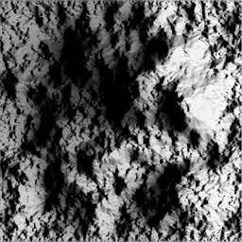 | 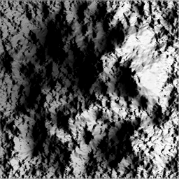 | 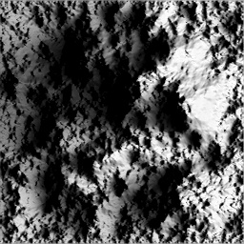 | 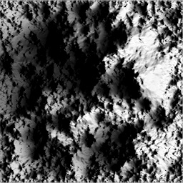 | 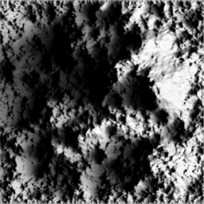
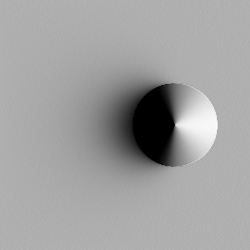 | 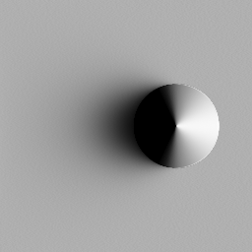 | 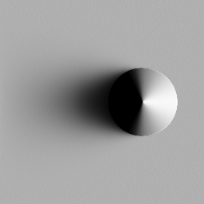 | 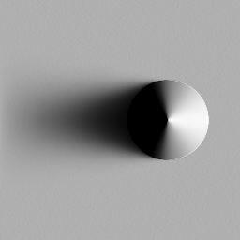 | 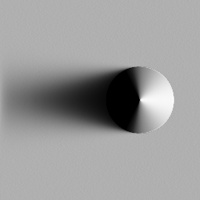
o=0 | o=1 | o=2 | o=3 | o=4
Figure 6: Effect of increasing the level offset o on shadow sharpness. In these two examples, k=4 and n=256. A scanline in the center of the fractal mountain in the top row is used to make the plot in Figure 4.

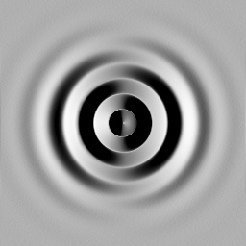 | 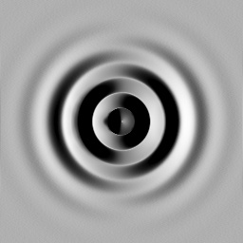 | 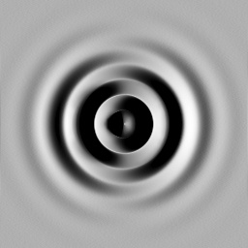 | 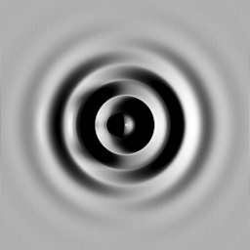 | 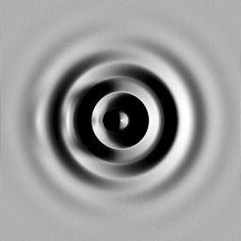
o=0, k=1 | o=1, k=1 | o=2, k=1 | o=3, k=1 | o=4, k=1
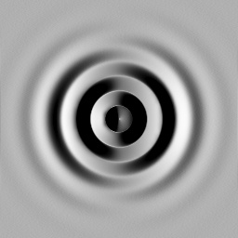 | 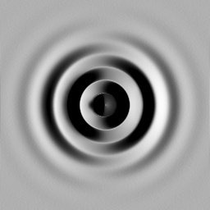 | 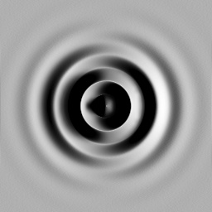 | 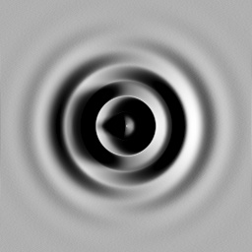
o=0, k=2 | o=1, k=2 | o=2, k=2 | o=3, k=2 | o=4, k=2
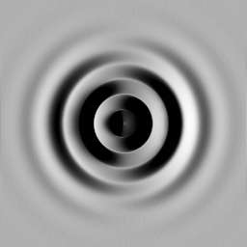 |  | 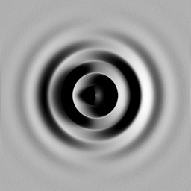 | 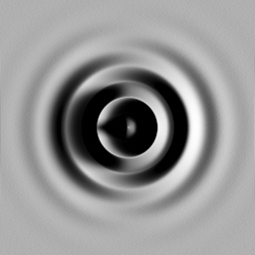 | 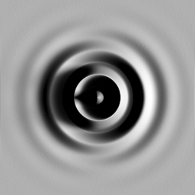
o=0, k=4 | o=1, k=4 | o=2, k=4 | o=3, k=4 | o=4, k=4
Figure 7: Aliasing with increasing level offset. At o ≥ 3 and k=1 (highlighted entries) there is significant aliasing in the shadow, which is eliminated using higher values of k, at the cost of increased sampling. The middle scanline of the top row is used to make the plot in Figure 5. Note also the lack of significant difference between the middle and bottom rows: k ≥2 sufficiently samples this geometry over this range of level offsets, $o≤4$.

Structure of the Visibility Computation (CPU)
The outermost loop is over azimuthal direction samples. We compute two passes for each azimuthal direction sample $φ_{i}$. The first pass computes blocking angle at each scale (3); the second pass computes maximum over all scales (5).
First pass (construct blocking angle pyramid $ω_{i}$ from height pyramid $f_{i}$):
[line 1] For each scale i
[line 2] For each receiver point $x$ in the height field $f_{i}\left(x\right)$at this pyramid level
[line 3] Compute (3) and output blocking angle to corresponding map $ω_{i}\left(x\right)$

Second pass (compute max blocking angle $ω$) :
[line 4] For each receiver point $x$ in the (highest resolution) height field $f\left(x\right)=f_{N}(x)$
[line 5] Sample $ω_{i}\left(x\right)$ using bicubic bspline interpolation for $i∈\{0,1,⋯,N\}$
[line 6] Compute (6) [max over bspline interpolation of above N+1 evaluations]

In our implementation, we compute line 2 above using bilinear interpolation in the pyramid level access. Line 5 however uses bicubic bspline interpolation which smoothes the coarser levels of the pyramid. Building the height field pyramid is done using successive bicubic bspline decimation steps (also called pyramid analysis).
We can speed up the second pass by not computing the max over the N+1 pyramid levels all at once, which requires expensive bspline resampling of each of the blocking angle maps $ω_{i}\left(x\right)$ to the finest resolution. Instead we perform the max over a smaller “bundle” of the coarsest levels (e.g. n_{b} =8), but only at the finest resolution of members of the bundle rather than the overall finest resolution. Then we can do the max over the next finer set of n_{b} levels, using an initial max we computed by resampling (again using bicubic bspline interpolation) the result of the previous bundle. Continuing in this way, we build up the max coarse-to-fine, and limit the bicubic resampling and max computations to an appropriate resolution at each stage. On the GPU, resampling of texture maps is much less costly than on the CPU and the savings per pass does not warrant the cost of the additional passes required by bundling.
Why do we bother computing the blocking angle (i.e., evaluating the inverse tangent)? First, an approximate inverse tangent is fast to evaluate, requiring just one divide (see Section 11). Second, doing the bspline interpolation in the space of blocking angles produces much better results than doing it in the space of tangents of blocking angles. The tangent of the blocking function is an unbounded function, and the effect of interpolating tangents is to overemphasize shadowing, since big blockers have big tangents whose influence is extended by interpolation.
To compute the max in (5), we just do a brute force evaluation at a number of sample points on the bspline, and then take the max. On the CPU, we can precompute the bspline weights and just perform a weighted sum of 4 consecutive $ω_{i}$ in order to accelerate this evaluation. Currently, in both the CPU and GPU implementations we sample the bspline at the every knot point ($t=i$) as well as halfway between each pair of knots ($t={(i+1)}/2$). For the evaluation at knot points, the bspline weights are $\{1/6,2/3,1/6,0\}$ and at the half-way points, they are $\left\{1/{48},{23}/{48},{23}/{48},1/{48}\right\}.$

Structure of the Visibility Computation (GPU)
On the GPU, we do a straightforward implementation of the visibility mathematics from Section 4. Equation (6) is evaluated in a single shader pass, over all pyramid levels (no bundling). We also build the height pyramid on-the-fly on the GPU given the highest resolution height field $f_{N}$, using successive bilinear decimation (to pre-filter the height field) followed by bspline interpolation back up to the original high resolution using the method in [Sigg05].

Shading with Spherical Harmonics
We represent the space of directions emanating from $p$ via unit vectors $s$ parameterized by azimuthal angle $φ∈[0,2π]$ and elevation angle $θ∈[{-π}/2,{+π}/2]$:
$$s\left(φ,θ\right)=\left(\cos{φ}\cos{θ},\sin{φ}\cos{θ},\sin{θ}\right).$$
The elevation angle is 0 if the corresponding direction skirts the height field plane, and $π/2$ if it points straight up, out of this plane.
At a given receiver point $x$, we obtain a sequence of blocking angles $ω\left(x,φ_{i}\right)$ over the azimuthal direction samples $φ_{i}$. Each consecutive pair of azimuthal directions $(φ_{i},φ_{i+1}$) determines a continuous blocking wedge as seen from $x$ with corresponding blocker angles $(ω_{i},ω_{i+1})$. To reconstruct a continuous function, $ω(φ)$, we simply assume that the blocking angle varies linearly from $ω_{i}$ to $ω_{i+1}$ as a function of $φ$ between $φ_{i}$ and $φ_{i+1}$. So
$$ω\left(φ\right)=ω_{i}+\frac{φ-φ_{i+1}}{Δ_{φ}}\left(ω_{i+1}-ω_{i}\right),$$
where the angular distance between azimuthal direction samples is denoted $Δ_{φ}=φ_{i+1}-φ_{i}$.
The blocking wedge visibility function is given by
$$v\left(φ,θ; φ_{i},φ_{i+1},ω_{i},ω_{i+1}\right)=\left\{\begin{matrix}0, & φ∈\left[φ_{i},φ_{i+1}\right] and θ≤ω(φ) \\ 1, & otherwise.\end{matrix}\right.$$
where $φ$ is the azimuthal component and $θ$ is the elevation component of each direction $s=(φ,θ)$. So v indicates whether a ray emanating from p in the direction $s$ misses the height field or not, and so is able to “see the sky” in that direction.
By canonically repositioning each blocking wedge so that $φ_{i}=0$, and assuming a fixed $Δ_{φ}$, we can precompute a low-order spherical harmonic (SH) projection of the blocking wedge function, in terms of the two blocking angles $(ω_{i},ω_{i+1})$. This can be stored as a 2D table which produces the SH visibility vector. Denote this table as $v\left(ω_{a},ω_{b}\right)$ (function is boldface since it produces an SH vector as output) and its corresponding continuous function as $v\left(s{; ω}_{a},ω_{b}\right)$. We use order-4 SH, which produces 16D visibility vectors. At run-time, we need to rotate the wedge vector around z to align it with the actual azimuthal origin $φ_{i}$, but this is a fast operation in the SH basis (see SH_rotatez_4 in Appendix).
The visibility wedge table $v\left(ω_{a},ω_{b}\right)$ is computed using numerical integration over the sphere $s∈S$ for each pair of elevation angles $\left(ω_{a},ω_{b}\right)$:
$$v_{i}\left(ω_{a},ω_{b}\right)=\int_{S}^{ }{v\left({s; ω}_{a},ω_{b}\right){ y}_{i}\left(s\right) ds}$$
where the SH basis function ${ y}_{i}\left(s\right)$ can be evaluated using SH_eval_basis_4 given in the Appendix. (Note: here i indexes the 16D components of the SH vector.)
For partial azimuthal swaths, we also tabulate starting and ending wedges, of azimuthal extent ${Δ_{φ}}/2$, as a function of a single elevation angle parameter.
We then add up the SH visibility vectors over all the blocking wedges for each consecutive pair of azimuthal direction samples. This gives the total SH visibility vector in the azimuthal swath, which we denote $V$.
Assuming a Lambertian (perfectly diffuse) receiver at x with unit normal vector $N_{x}$, shading is the SH triple product of clamped cosine hemisphere around the normal vector, $H(N_{x})$, visibility vector, $V_{x}$, and the (constant) SH lighting vector, $L$. To compute the shading given these three SH vectors, we can compute the binary SH product $T_{x}=H\left(N_{x}\right)*V_{x}$, called the transfer vector, using SH_product_4 given in the Appendix. The shade is then given simply by the vector dot product, $T_{x}∙L$. By computing the transfer vector, we can easily recompute the shade with a different lighting vector simply by recomputing this 16D dot product with a different $L$. Alternatively, if the light is fixed we can compute the SH triple product directly (SH_tensor_4 in Appendix). The derivation of these routines is further described in [Snyder06].
To compute $H(N_{x})$, representing Lambertian reflectance of the receiver point, we use the routine SH_zh_rot_4 given in the appendix. The zonal harmonic coefficients (components restricted to the subset of SH basis functions that are circularly symmetric around z) for the clamped cosine function oriented around the z axis can be found analytically [Ramamoorthi01] or by numerical integration, yielding the following values:
static float zhemi_canon[4] = {
0.886227,1.02333,0.495416,0
};
Calling SH_zh_rot_4 with its first argument as $N_{x}$ and the second as zhemi_canon above then returns the correct vector $H(N_{x})$.
For small azimuthal swaths, this method actually obtains much sharper shadows than can ordinarily be realized with low order SH. This is because our visibility basis functions are restricted (and precomputed) for these small blocking wedges. As the azimuthal swath approaches the complete swath, the shadow sharpness decreases until it is ultimately limited by the SH order used. For example, the right columns of the bottom row of Figure 6 show shadows from a cone that are much sharper than can be realized with complete swath visibility at SH order 4. In this case, the azimuthal wedge spanned just 20°.

Key Lights and Environmental Lights
To shade the height field, we use two different types of light sources. Environmental light comes from all around the height field, and uses a complete azimuthal swath. Key light represents a smaller, more directional light source using a partial azimuthal swath. We must recompute the SH visibility vector for the key light as it is moved during interaction. For environmental light, once the visibility vector is computed for the full swath, it need not be recomputed as the environmental light is changed or rotated. In summary:
Environmental light: provides very soft shadows for light that comes from overhead or all around the height field. Visibility is sampled in a complete swath and so requires many samples (typically 16-32 for order-4 SH). Once computed, the visibility can apply to any lighting environment and in particular allows rotation of the lighting. Note a full wedge produces softer shadows than a partial wedge, even with the same SH lighting vector. Our current implementation uses environmental light from HDR light probes [Debevec98] or analytic circular sources.
Key light: provides more directional shadows. It focuses azimuthal direction samples within a narrow range specialized to where the (key) light comes from. Restricting SH visibility to a small azimuthal wedge also yields sharper shadows. Visibility must be recomputed as the light source moves.
Another optimization: don’t do 1D bspline for environmental light. Take max only over pyramid levels. Also saves computing inverse tangent at each level.
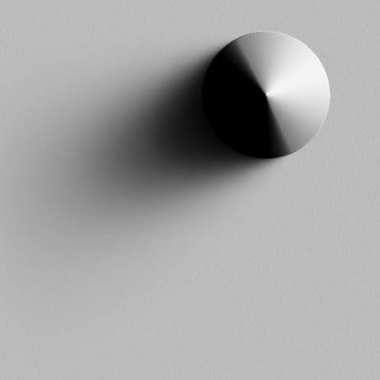 | 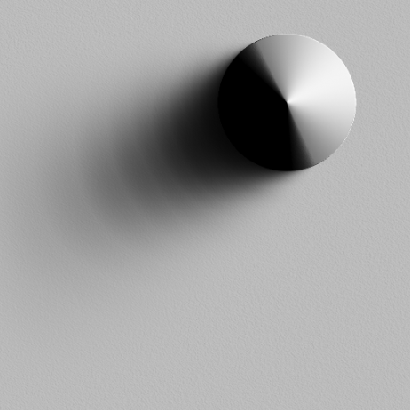
- bspline (1d & 2d) | - linear (1d), bspline (2d)
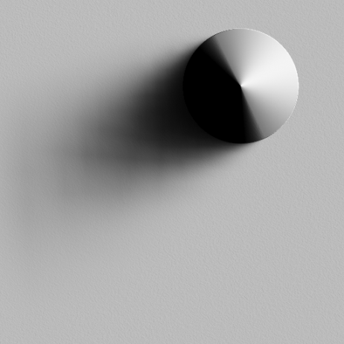 | 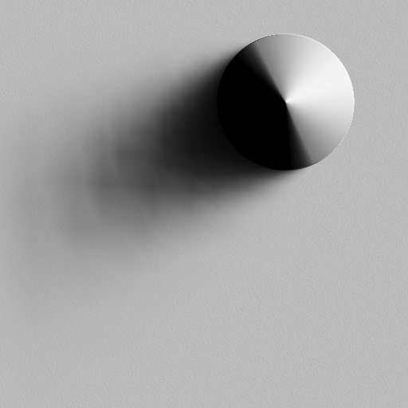
- bspline (1d), bilinear (2d) | - linear (1d), bilinear (2d)
Figure 8: Effect of different reconstruction methods on soft shadows. Interpolation is invoked in 1d to reconstruct a continuous function over scale space in (4), and in 2D when evaluating the multi-scale derivative in (2). Using smooth (C²) functions like bsplines for both these reconstructions is necessary to provide a smooth, natural-looking shadow, shown in (a).

Results

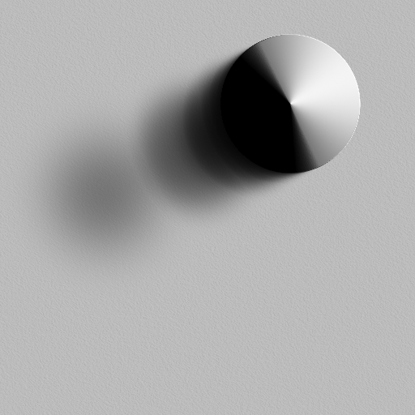 | 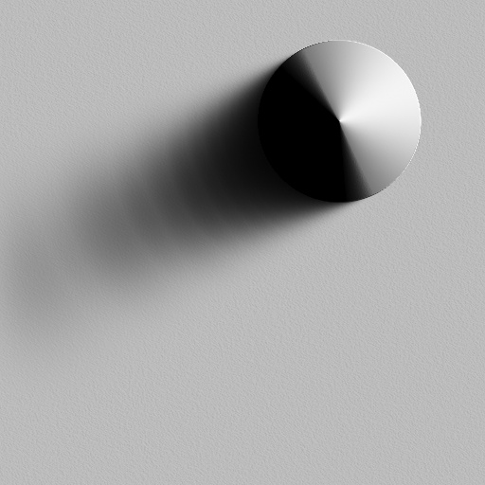
- k=1 | - k=2
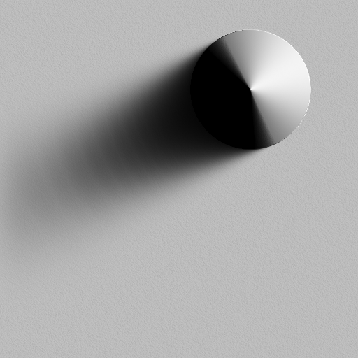 | 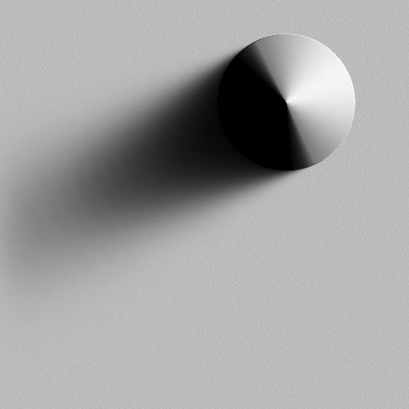
- k=3 | - k=4
Figure 9: Effect of level step k on soft shadows. In all four examples, the level offset is fixed at o=3. Increasing the level step eliminates aliasing and makes the shadow smoother. Power-of-2 pyramids don’t always suffice. In this case, using four levels per power of two step (k=4) provides a good result, shown in (d).

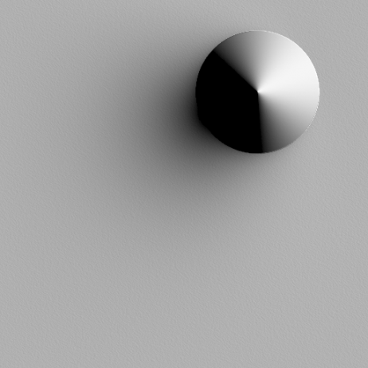 | 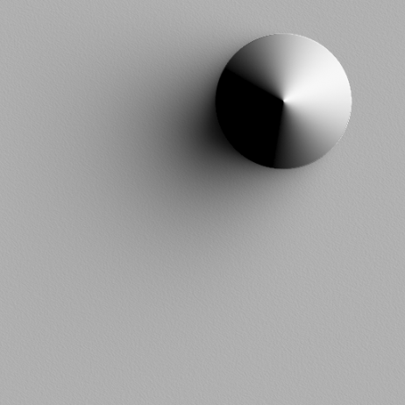 | 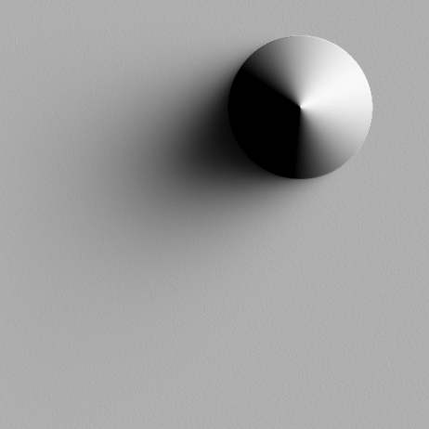
$∆_{Φ}$=180° | $∆_{Φ}$=90° | $∆_{Φ}$=45°
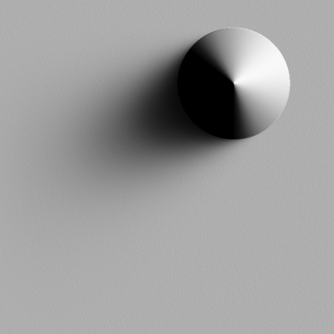 | 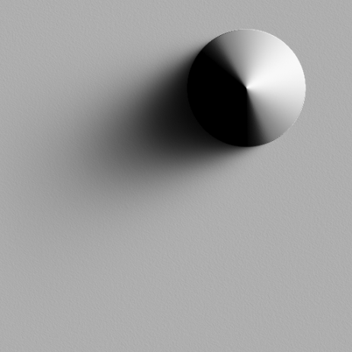 | 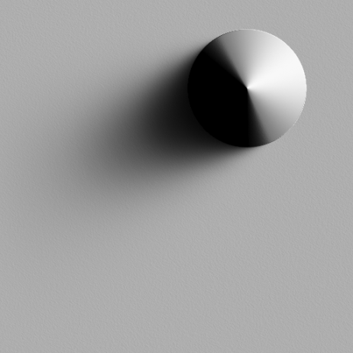
$∆_{Φ}$=22.5° | $∆_{Φ}$=11.25° | $∆_{Φ}$=5.63°
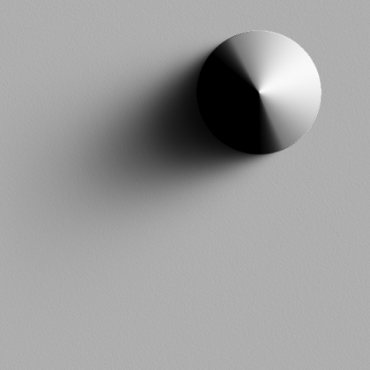 | 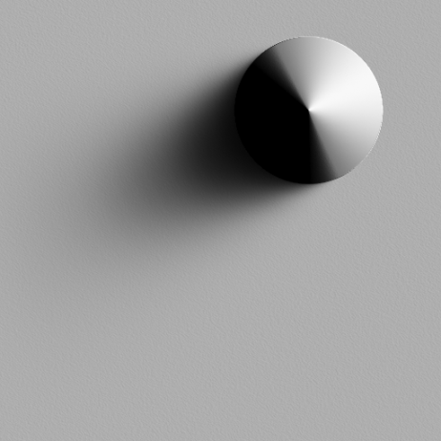 | 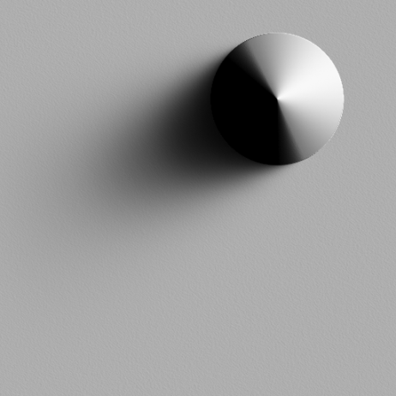
$∆_{Φ}$=2.81° | $∆_{Φ}$=1.41° | $∆_{Φ}$=0.70°
Figure 10: Effect of azimuthal swath size $∆_{Φ}$on soft shadows. As the swath narrows, the shadows become sharper. In this example, the lighting is fixed as the “peakiest” light that can be represented with SH order 4, but is normalized to produce unit maximum shading when the receiver is unshadowed. By restricting the swath size, we can obtain sharper shadows than can ordinarily be obtained with a given SH order. Note also that the shadow does not get arbitrarily sharper, but converges to a given softness which depends on the lighting. There is very little visual difference between images in the bottom row.

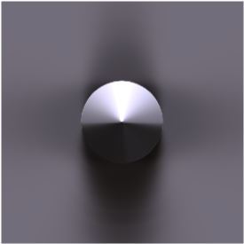 | 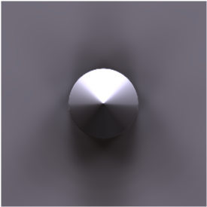
$n_{φ}=4$ | $$n_{φ}=8$$
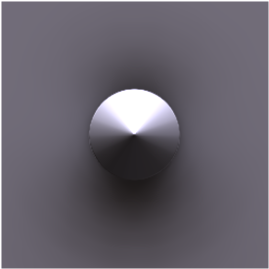 | 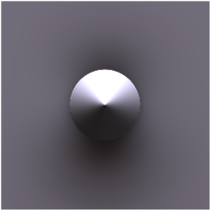
$$n_{φ}=16$$ | $$n_{φ}=32$$
Figure 11: Effect of number of azimuthal samples, $n_φ$. In this experiment, the cone is lit by the “Uffizi” light probe [Debevec98]. At least 16 azimuthal samples are needed to eliminate aliasing. Using 32 samples improves results slightly, as can be seen in the shading of the cone itself.

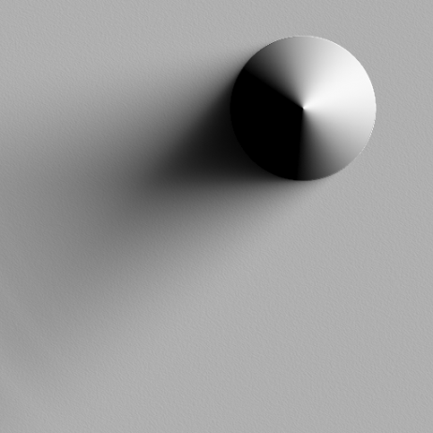 | 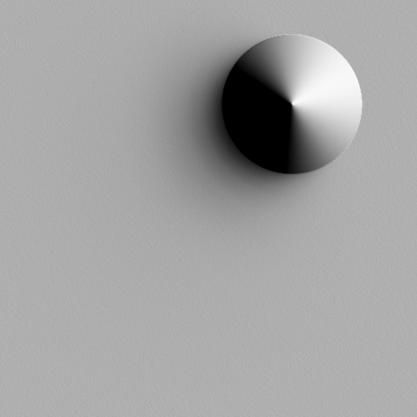 | 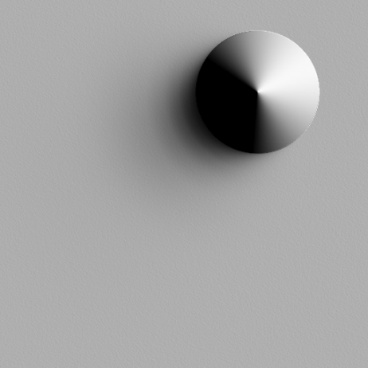
- ground truth (N=145) | - k=1, o=0 (N=10) | - k =1, o=1 (N=10)
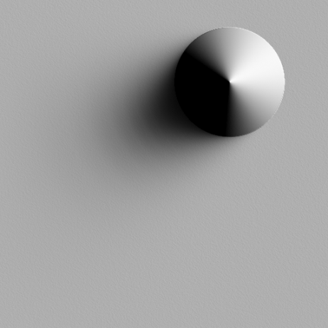 | 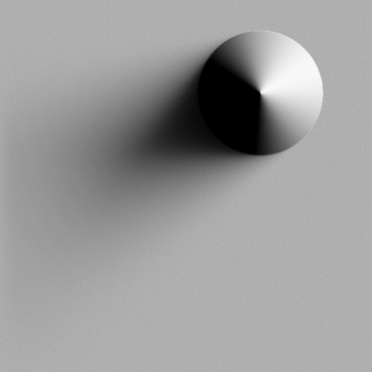 | 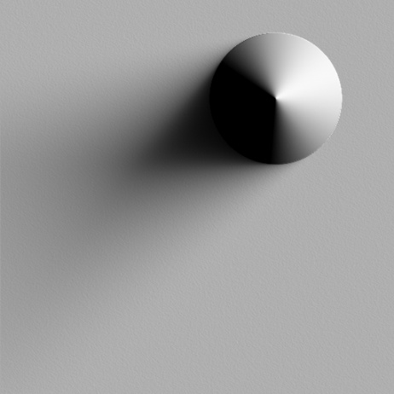
- k =2, o=2 (N=19) | - k =4, o=4 (N=37) | - k =8, o=8 (N=73)
Figure 12: Comparison with ground truth. As we increase the level offset, we obtain a more exact approximation of the height field geometry. The resulting soft shadows converge to the ground truth result in (a). The ground truth image was generated by applying (1) using a large number of samples distributed linearly with distance rather than logarithmically.

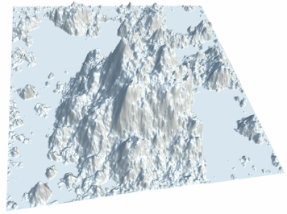 | 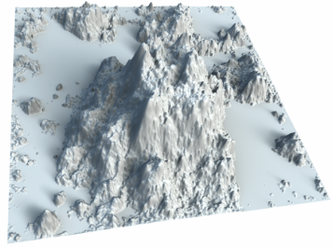 | 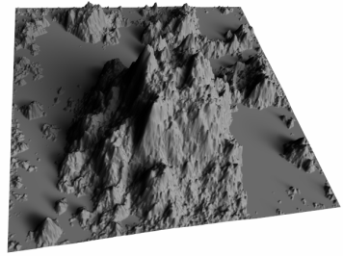
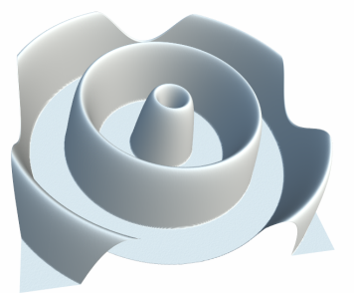 | 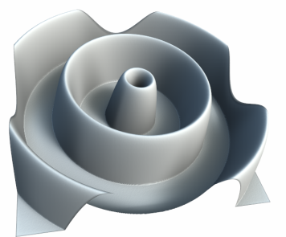 | 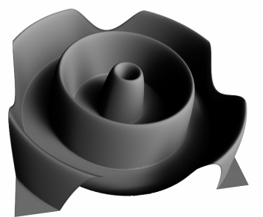
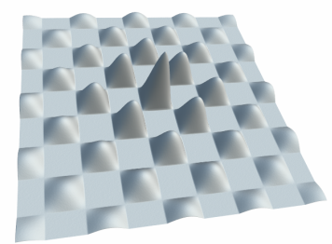 | 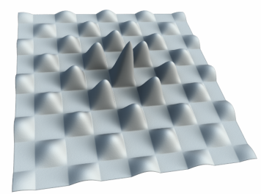 | 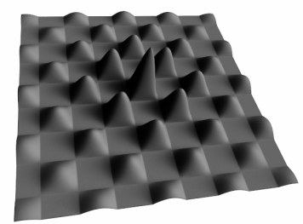
- unshadowed | - shadowed (key + env.) | - key only
Figure 13: Soft shadows on various geometries (rows). The key light source is an SH order-4 delta function arriving over the viewer’s right shoulder, while the environment light is from an HDR light probe converted to the SH basis.

References

[Bunnell05] Michael Bunnell, Dynamic ambient occlusion and indirect lighting, in GPU Gems 2: Programming Techniques for High-Performance Graphics and General-Purpose Computation, Edited by M. Pharr, Addison-Wesley, Boston, 2005.
[Burt81] P. J. Burt, Fast filter transforms for image processing, Computer Graphics and Image processing, 1981, 16:2-51.
[Debevec98] Paul Debevec, Rendering synthetic objects into real scenes: bridging traditional and image-based graphics with global illumination and high dynamic range photography, ACM SIGGRAPH, July 1998, 189-198. [link]
[Hastings53] Cecil Hastings, Jr., Approximation Theory, Note 143, Math. Tables Aids. Comp 6, 68 (1953).
[Kontkanen05] Janne Kontkanen and Samuli Laine, Ambient occlusion fields, Symposium on Interactive 3D Graphics, April 2005, 41-48. [link]
[Max88] Nelson Max, Horizon mapping: shadows for bump-mapped surfaces, The Visual Computer 4(2), March 1988, 109-117. [link]
[Oat07] Christopher Oat and Pedro Sander, Ambient aperture lighting, ACM SIGGRAPH Symposium on Interactive 3D Graphics and Games (I3D 2007), May 2007, 61-64. [link]
[Sloan02] Peter-Pike Sloan, Jan Kautz, and John Snyder, Precomputed radiance transfer for real-time rendering in dynamic, low-frequency lighting environments, ACM SIGGRAPH, July 2002, 527-536. [link]
[Sloan07] Peter-Pike Sloan, Naga Govindaraju, Derek Nowrouzezahrai, and John Snyder, Image-based proxy accumulation for real-time soft global illumination, Pacific Graphics, October 2007, 97-105. [link]
[Ramamoorthi01] Ravi Ramamoorthi and Pat Hanrahan, An efficient representation for irradiance environment maps, ACM SIGGRAPH, August 2001, 497-500. [link]
[Ren06] Zhong Ren, Rui Wang, John Snyder, Kun Zhou, Xinguo Liu, Bo Sun, Peter-Pike Sloan, Hujun Bao, Qunsheng Peng, and Baining Guo, Real-Time Soft Shadows in Dynamic Scenes using Spherical Harmonic Exponentiation, ACM SIGGRAPH, August 2006, 977-986. [link]
[Segal92] Mark Segal, Carl Korobkin, Rolf van Widenfelt, Jim Foran, and Paul Haeberli, Fast shadows and lighting effects using texture mapping, Proceedings of ACM SIGGRAPH 92, 249-252. [link]
[Sigg05] Christian Sigg and Markus Hadwiger, Fast third-order texture filtering, in GPU Gems 2: Programming Techniques for High-Performance Graphics and General-Purpose Computation, Edited by M. Pharr, Addison-Wesley, Boston, 2005.
[Shanmugam07] Perumaal Shanmugam and Okan Arikan, Hardware accelerated ambient occlusion techniques on GPUs, Symposium on Interactive 3D Graphics, April 2007, 73-80. [link]
[Snyder06] John Snyder, Code generation and factoring for fast evaluation of low-order spherical harmonic products and squares, Microsoft Technical Report, MSR-TR-2006-53, May 2006. [link]
[Williams78] Lance Williams, Casting curved shadows on curved surfaces, Proceedings of ACM SIGGRAPH 78, 270-274. [link]
[William83] Lance Williams, Pyramidal parametrics, Proceedings of ACM SIGGRAPH 83, July 1983, 1-11. [link]

Appendix

Fast inverse tangent [Hastings]:
#define HALF_PI 1.5707963f
static inline float atanf_fast(float x)
{
if (fabsf(x) < 1.0f) {
return x/(1.0f + 0.28f*x*x);
} else { // atan(x) = pi/2 - atan(1/x) using above formula for atan
if (x >= 0.0f) return HALF_PI - x/(x*x + 0.28f);
else return -HALF_PI - x/(x*x + 0.28f); // subtract pi
}
}

Order-4 SH routines (CPU code to evaluate SH basis functions, rotate around z, compute binary and triple products):
#include <math.h>

#define CONSTANT(x) float(x)

//
// Rotate SH vector in Y around z axis by angle whose cosine and sine
// are given by the first two arguments, respectively. The result
// is added into the output vector Yr.
//
void SH_rotatez_4(float c,float s,const float Y[],float Yr[])
{
float cm = c;
float sm = s;
float newcm;

// m=0
Yr[ 0] = Y[ 0];
Yr[ 2] = Y[ 2];
Yr[ 6] = Y[ 6];
Yr[12] = Y[12];

// m=1
Yr[ 1] = cm*Y[ 1] + sm*Y[ 3];
Yr[ 3] = cm*Y[ 3] - sm*Y[ 1];
Yr[ 5] = cm*Y[ 5] + sm*Y[ 7];
Yr[ 7] = cm*Y[ 7] - sm*Y[ 5];
Yr[11] = cm*Y[11] + sm*Y[13];
Yr[13] = cm*Y[13] - sm*Y[11];

newcm = c*cm - s*sm;
sm = c*sm + s*cm;
cm = newcm;

// m=2
Yr[ 4] = cm*Y[ 4] + sm*Y[ 8];
Yr[ 8] = cm*Y[ 8] - sm*Y[ 4];
Yr[10] = cm*Y[10] + sm*Y[14];
Yr[14] = cm*Y[14] - sm*Y[10];

newcm = c*cm - s*sm;
sm = c*sm + s*cm;
cm = newcm;

// m=3
Yr[ 9] = cm*Y[ 9] + sm*Y[15];
Yr[15] = cm*Y[15] - sm*Y[ 9];
}

// routine generated programmatically for evaluating SH basis for degree 3
// inputs (x,y,z) are a point on the sphere (i.e., must be unit length)
// output is vector b with SH basis evaluated at (x,y,z).
//
void SH_eval_basis_4(float x,float y,float z,float b[16]) {
const float z2 = z*z;

/* m=0 */

// l=0
const float p_0_0 = CONSTANT(0.282094791773878140);
b[ 0] = p_0_0; // l=0,m=0
// l=1
const float p_1_0 = CONSTANT(0.488602511902919920)*z;
b[ 2] = p_1_0; // l=1,m=0
// l=2
const float p_2_0 = CONSTANT(0.946174695757560080)*z2 + CONSTANT(-0.315391565252520050);
b[ 6] = p_2_0; // l=2,m=0
// l=3
const float p_3_0 = z*(CONSTANT(1.865881662950577000)*z2 + CONSTANT(-1.119528997770346200));
b[ 12] = p_3_0; // l=3,m=0

/* m=1 */

const float s_1 = y;
const float c_1 = x;

// l=1
const float p_1_1 = CONSTANT(-0.488602511902919920);
b[ 1] = p_1_1*s_1; // l=1,m=-1
b[ 3] = p_1_1*c_1; // l=1,m=+1
// l=2
const float p_2_1 = CONSTANT(-1.092548430592079200)*z;
b[ 5] = p_2_1*s_1; // l=2,m=-1
b[ 7] = p_2_1*c_1; // l=2,m=+1
// l=3
const float p_3_1 = CONSTANT(-2.285228997322328800)*z2 + CONSTANT(0.457045799464465770);
b[ 11] = p_3_1*s_1; // l=3,m=-1
b[ 13] = p_3_1*c_1; // l=3,m=+1

/* m=2 */

const float s_2 = x*s_1 + y*c_1;
const float c_2 = x*c_1 - y*s_1;

// l=2
const float p_2_2 = CONSTANT(0.546274215296039590);
b[ 4] = p_2_2*s_2; // l=2,m=-2
b[ 8] = p_2_2*c_2; // l=2,m=+2
// l=3
const float p_3_2 = CONSTANT(1.445305721320277100)*z;
b[ 10] = p_3_2*s_2; // l=3,m=-2
b[ 14] = p_3_2*c_2; // l=3,m=+2

/* m=3 */

const float s_3 = x*s_2 + y*c_2;
const float c_3 = x*c_2 - y*s_2;

// l=3
const float p_3_3 = CONSTANT(-0.590043589926643520);
b[ 9] = p_3_3*s_3; // l=3,m=-3
b[ 15] = p_3_3*c_3; // l=3,m=+3
}

//
// Rotate ZH (zonal harmonic, function circularly symmetric about z axis) around z axis
// output is placed in y
//
void SH_zh_rot_4(const float a[3],const float zh[],float y[])
{
static const float M_PI = atanf(1.0)*4.0;
static float L[] = {
sqrtf(4*M_PI/(2*0+1)),
sqrtf(4*M_PI/(2*1+1)),
sqrtf(4*M_PI/(2*2+1)),
sqrtf(4*M_PI/(2*3+1)),
}; // L[i] = sqrt(4*M_PI/(2*i+1));

SH_eval_basis_4(a[0],a[1],a[2],y);

float F0 = zh[0]*L[0];
float F1 = zh[1]*L[1];
float F2 = zh[2]*L[2];
float F3 = zh[3]*L[3];

y[ 0] *= F0;
y[ 1] *= F1;
y[ 2] *= F1;
y[ 3] *= F1;
y[ 4] *= F2;
y[ 5] *= F2;
y[ 6] *= F2;
y[ 7] *= F2;
y[ 8] *= F2;
y[ 9] *= F3;
y[10] *= F3;
y[11] *= F3;
y[12] *= F3;
y[13] *= F3;
y[14] *= F3;
y[15] *= F3;
}

//
// routine generated programatically
// Multiply SH vectors f and g resulting in output SH vector y.
//
void SH_product_4(const float *f,const float *g,float *y) {
register float tf,tg,t;
// [0,0]: 0,
y[0] = CONSTANT(0.282094792935999980)*f[0]*g[0];

// [1,1]: 0,6,8,
tf = CONSTANT(0.282094791773000010)*f[0]+CONSTANT(-0.126156626101000010)*f[6]+CONSTANT(-0.218509686119999990)*f[8];
tg = CONSTANT(0.282094791773000010)*g[0]+CONSTANT(-0.126156626101000010)*g[6]+CONSTANT(-0.218509686119999990)*g[8];
y[1] = tf*g[1]+tg*f[1];
t = f[1]*g[1];
y[0] += CONSTANT(0.282094791773000010)*t;
y[6] = CONSTANT(-0.126156626101000010)*t;
y[8] = CONSTANT(-0.218509686119999990)*t;

// [1,4]: 3,13,15,
tf = CONSTANT(0.218509686114999990)*f[3]+CONSTANT(-0.058399170082300000)*f[13]+CONSTANT(-0.226179013157999990)*f[15];
tg = CONSTANT(0.218509686114999990)*g[3]+CONSTANT(-0.058399170082300000)*g[13]+CONSTANT(-0.226179013157999990)*g[15];
y[1] += tf*g[4]+tg*f[4];
y[4] = tf*g[1]+tg*f[1];
t = f[1]*g[4]+f[4]*g[1];
y[3] = CONSTANT(0.218509686114999990)*t;
y[13] = CONSTANT(-0.058399170082300000)*t;
y[15] = CONSTANT(-0.226179013157999990)*t;

// [1,5]: 2,12,14,
tf = CONSTANT(0.218509686118000010)*f[2]+CONSTANT(-0.143048168103000000)*f[12]+CONSTANT(-0.184674390923000000)*f[14];
tg = CONSTANT(0.218509686118000010)*g[2]+CONSTANT(-0.143048168103000000)*g[12]+CONSTANT(-0.184674390923000000)*g[14];
y[1] += tf*g[5]+tg*f[5];
y[5] = tf*g[1]+tg*f[1];
t = f[1]*g[5]+f[5]*g[1];
y[2] = CONSTANT(0.218509686118000010)*t;
y[12] = CONSTANT(-0.143048168103000000)*t;
y[14] = CONSTANT(-0.184674390923000000)*t;

// [1,6]: 11,
tf = CONSTANT(0.202300659402999990)*f[11];
tg = CONSTANT(0.202300659402999990)*g[11];
y[1] += tf*g[6]+tg*f[6];
y[6] += tf*g[1]+tg*f[1];
t = f[1]*g[6]+f[6]*g[1];
y[11] = CONSTANT(0.202300659402999990)*t;

// [1,8]: 9,11,
tf = CONSTANT(0.226179013155000000)*f[9]+CONSTANT(0.058399170081799998)*f[11];
tg = CONSTANT(0.226179013155000000)*g[9]+CONSTANT(0.058399170081799998)*g[11];
y[1] += tf*g[8]+tg*f[8];
y[8] += tf*g[1]+tg*f[1];
t = f[1]*g[8]+f[8]*g[1];
y[9] = CONSTANT(0.226179013155000000)*t;
y[11] += CONSTANT(0.058399170081799998)*t;

// [2,2]: 0,6,
tf = CONSTANT(0.282094795249000000)*f[0]+CONSTANT(0.252313259986999990)*f[6];
tg = CONSTANT(0.282094795249000000)*g[0]+CONSTANT(0.252313259986999990)*g[6];
y[2] += tf*g[2]+tg*f[2];
t = f[2]*g[2];
y[0] += CONSTANT(0.282094795249000000)*t;
y[6] += CONSTANT(0.252313259986999990)*t;

// [2,6]: 12,
tf = CONSTANT(0.247766706973999990)*f[12];
tg = CONSTANT(0.247766706973999990)*g[12];
y[2] += tf*g[6]+tg*f[6];
y[6] += tf*g[2]+tg*f[2];
t = f[2]*g[6]+f[6]*g[2];
y[12] += CONSTANT(0.247766706973999990)*t;

// [3,3]: 0,6,8,
tf = CONSTANT(0.282094791773000010)*f[0]+CONSTANT(-0.126156626101000010)*f[6]+CONSTANT(0.218509686119999990)*f[8];
tg = CONSTANT(0.282094791773000010)*g[0]+CONSTANT(-0.126156626101000010)*g[6]+CONSTANT(0.218509686119999990)*g[8];
y[3] += tf*g[3]+tg*f[3];
t = f[3]*g[3];
y[0] += CONSTANT(0.282094791773000010)*t;
y[6] += CONSTANT(-0.126156626101000010)*t;
y[8] += CONSTANT(0.218509686119999990)*t;

// [3,6]: 13,
tf = CONSTANT(0.202300659402999990)*f[13];
tg = CONSTANT(0.202300659402999990)*g[13];
y[3] += tf*g[6]+tg*f[6];
y[6] += tf*g[3]+tg*f[3];
t = f[3]*g[6]+f[6]*g[3];
y[13] += CONSTANT(0.202300659402999990)*t;

// [3,7]: 2,12,14,
tf = CONSTANT(0.218509686118000010)*f[2]+CONSTANT(-0.143048168103000000)*f[12]+CONSTANT(0.184674390923000000)*f[14];
tg = CONSTANT(0.218509686118000010)*g[2]+CONSTANT(-0.143048168103000000)*g[12]+CONSTANT(0.184674390923000000)*g[14];
y[3] += tf*g[7]+tg*f[7];
y[7] = tf*g[3]+tg*f[3];
t = f[3]*g[7]+f[7]*g[3];
y[2] += CONSTANT(0.218509686118000010)*t;
y[12] += CONSTANT(-0.143048168103000000)*t;
y[14] += CONSTANT(0.184674390923000000)*t;

// [3,8]: 13,15,
tf = CONSTANT(-0.058399170081799998)*f[13]+CONSTANT(0.226179013155000000)*f[15];
tg = CONSTANT(-0.058399170081799998)*g[13]+CONSTANT(0.226179013155000000)*g[15];
y[3] += tf*g[8]+tg*f[8];
y[8] += tf*g[3]+tg*f[3];
t = f[3]*g[8]+f[8]*g[3];
y[13] += CONSTANT(-0.058399170081799998)*t;
y[15] += CONSTANT(0.226179013155000000)*t;

// [4,4]: 0,6,
tf = CONSTANT(0.282094791770000020)*f[0]+CONSTANT(-0.180223751576000010)*f[6];
tg = CONSTANT(0.282094791770000020)*g[0]+CONSTANT(-0.180223751576000010)*g[6];
y[4] += tf*g[4]+tg*f[4];
t = f[4]*g[4];
y[0] += CONSTANT(0.282094791770000020)*t;
y[6] += CONSTANT(-0.180223751576000010)*t;

// [4,5]: 7,
tf = CONSTANT(0.156078347226000000)*f[7];
tg = CONSTANT(0.156078347226000000)*g[7];
y[4] += tf*g[5]+tg*f[5];
y[5] += tf*g[4]+tg*f[4];
t = f[4]*g[5]+f[5]*g[4];
y[7] += CONSTANT(0.156078347226000000)*t;

// [4,9]: 3,13,
tf = CONSTANT(0.226179013157999990)*f[3]+CONSTANT(-0.094031597258400004)*f[13];
tg = CONSTANT(0.226179013157999990)*g[3]+CONSTANT(-0.094031597258400004)*g[13];
y[4] += tf*g[9]+tg*f[9];
y[9] += tf*g[4]+tg*f[4];
t = f[4]*g[9]+f[9]*g[4];
y[3] += CONSTANT(0.226179013157999990)*t;
y[13] += CONSTANT(-0.094031597258400004)*t;

// [4,10]: 2,12,
tf = CONSTANT(0.184674390919999990)*f[2]+CONSTANT(-0.188063194517999990)*f[12];
tg = CONSTANT(0.184674390919999990)*g[2]+CONSTANT(-0.188063194517999990)*g[12];
y[4] += tf*g[10]+tg*f[10];
y[10] = tf*g[4]+tg*f[4];
t = f[4]*g[10]+f[10]*g[4];
y[2] += CONSTANT(0.184674390919999990)*t;
y[12] += CONSTANT(-0.188063194517999990)*t;

// [4,11]: 3,13,15,
tf = CONSTANT(-0.058399170082300000)*f[3]+CONSTANT(0.145673124078000010)*f[13]+CONSTANT(0.094031597258400004)*f[15];
tg = CONSTANT(-0.058399170082300000)*g[3]+CONSTANT(0.145673124078000010)*g[13]+CONSTANT(0.094031597258400004)*g[15];
y[4] += tf*g[11]+tg*f[11];
y[11] += tf*g[4]+tg*f[4];
t = f[4]*g[11]+f[11]*g[4];
y[3] += CONSTANT(-0.058399170082300000)*t;
y[13] += CONSTANT(0.145673124078000010)*t;
y[15] += CONSTANT(0.094031597258400004)*t;

// [5,5]: 0,6,8,
tf = CONSTANT(0.282094791773999990)*f[0]+CONSTANT(0.090111875786499998)*f[6]+CONSTANT(-0.156078347227999990)*f[8];
tg = CONSTANT(0.282094791773999990)*g[0]+CONSTANT(0.090111875786499998)*g[6]+CONSTANT(-0.156078347227999990)*g[8];
y[5] += tf*g[5]+tg*f[5];
t = f[5]*g[5];
y[0] += CONSTANT(0.282094791773999990)*t;
y[6] += CONSTANT(0.090111875786499998)*t;
y[8] += CONSTANT(-0.156078347227999990)*t;

// [5,9]: 14,
tf = CONSTANT(0.148677009677999990)*f[14];
tg = CONSTANT(0.148677009677999990)*g[14];
y[5] += tf*g[9]+tg*f[9];
y[9] += tf*g[5]+tg*f[5];
t = f[5]*g[9]+f[9]*g[5];
y[14] += CONSTANT(0.148677009677999990)*t;

// [5,10]: 3,13,15,
tf = CONSTANT(0.184674390919999990)*f[3]+CONSTANT(0.115164716490000000)*f[13]+CONSTANT(-0.148677009678999990)*f[15];
tg = CONSTANT(0.184674390919999990)*g[3]+CONSTANT(0.115164716490000000)*g[13]+CONSTANT(-0.148677009678999990)*g[15];
y[5] += tf*g[10]+tg*f[10];
y[10] += tf*g[5]+tg*f[5];
t = f[5]*g[10]+f[10]*g[5];
y[3] += CONSTANT(0.184674390919999990)*t;
y[13] += CONSTANT(0.115164716490000000)*t;
y[15] += CONSTANT(-0.148677009678999990)*t;

// [5,11]: 2,12,14,
tf = CONSTANT(0.233596680327000010)*f[2]+CONSTANT(0.059470803871800003)*f[12]+CONSTANT(-0.115164716491000000)*f[14];
tg = CONSTANT(0.233596680327000010)*g[2]+CONSTANT(0.059470803871800003)*g[12]+CONSTANT(-0.115164716491000000)*g[14];
y[5] += tf*g[11]+tg*f[11];
y[11] += tf*g[5]+tg*f[5];
t = f[5]*g[11]+f[11]*g[5];
y[2] += CONSTANT(0.233596680327000010)*t;
y[12] += CONSTANT(0.059470803871800003)*t;
y[14] += CONSTANT(-0.115164716491000000)*t;

// [6,6]: 0,6,
tf = CONSTANT(0.282094797560000000)*f[0];
tg = CONSTANT(0.282094797560000000)*g[0];
y[6] += tf*g[6]+tg*f[6];
t = f[6]*g[6];
y[0] += CONSTANT(0.282094797560000000)*t;
y[6] += CONSTANT(0.180223764527000010)*t;

// [7,7]: 0,6,8,
tf = CONSTANT(0.282094791773999990)*f[0]+CONSTANT(0.090111875786499998)*f[6]+CONSTANT(0.156078347227999990)*f[8];
tg = CONSTANT(0.282094791773999990)*g[0]+CONSTANT(0.090111875786499998)*g[6]+CONSTANT(0.156078347227999990)*g[8];
y[7] += tf*g[7]+tg*f[7];
t = f[7]*g[7];
y[0] += CONSTANT(0.282094791773999990)*t;
y[6] += CONSTANT(0.090111875786499998)*t;
y[8] += CONSTANT(0.156078347227999990)*t;

// [7,10]: 1,9,11,
tf = CONSTANT(0.184674390919999990)*f[1]+CONSTANT(0.148677009678999990)*f[9]+CONSTANT(0.115164716490000000)*f[11];
tg = CONSTANT(0.184674390919999990)*g[1]+CONSTANT(0.148677009678999990)*g[9]+CONSTANT(0.115164716490000000)*g[11];
y[7] += tf*g[10]+tg*f[10];
y[10] += tf*g[7]+tg*f[7];
t = f[7]*g[10]+f[10]*g[7];
y[1] += CONSTANT(0.184674390919999990)*t;
y[9] += CONSTANT(0.148677009678999990)*t;
y[11] += CONSTANT(0.115164716490000000)*t;

// [7,13]: 2,12,14,
tf = CONSTANT(0.233596680327000010)*f[2]+CONSTANT(0.059470803871800003)*f[12]+CONSTANT(0.115164716491000000)*f[14];
tg = CONSTANT(0.233596680327000010)*g[2]+CONSTANT(0.059470803871800003)*g[12]+CONSTANT(0.115164716491000000)*g[14];
y[7] += tf*g[13]+tg*f[13];
y[13] += tf*g[7]+tg*f[7];
t = f[7]*g[13]+f[13]*g[7];
y[2] += CONSTANT(0.233596680327000010)*t;
y[12] += CONSTANT(0.059470803871800003)*t;
y[14] += CONSTANT(0.115164716491000000)*t;

// [7,14]: 15,
tf = CONSTANT(0.148677009677999990)*f[15];
tg = CONSTANT(0.148677009677999990)*g[15];
y[7] += tf*g[14]+tg*f[14];
y[14] += tf*g[7]+tg*f[7];
t = f[7]*g[14]+f[14]*g[7];
y[15] += CONSTANT(0.148677009677999990)*t;

// [8,8]: 0,6,
tf = CONSTANT(0.282094791770000020)*f[0]+CONSTANT(-0.180223751576000010)*f[6];
tg = CONSTANT(0.282094791770000020)*g[0]+CONSTANT(-0.180223751576000010)*g[6];
y[8] += tf*g[8]+tg*f[8];
t = f[8]*g[8];
y[0] += CONSTANT(0.282094791770000020)*t;
y[6] += CONSTANT(-0.180223751576000010)*t;

// [8,9]: 11,
tf = CONSTANT(-0.094031597259499999)*f[11];
tg = CONSTANT(-0.094031597259499999)*g[11];
y[8] += tf*g[9]+tg*f[9];
y[9] += tf*g[8]+tg*f[8];
t = f[8]*g[9]+f[9]*g[8];
y[11] += CONSTANT(-0.094031597259499999)*t;

// [8,13]: 15,
tf = CONSTANT(-0.094031597259499999)*f[15];
tg = CONSTANT(-0.094031597259499999)*g[15];
y[8] += tf*g[13]+tg*f[13];
y[13] += tf*g[8]+tg*f[8];
t = f[8]*g[13]+f[13]*g[8];
y[15] += CONSTANT(-0.094031597259499999)*t;

// [8,14]: 2,12,
tf = CONSTANT(0.184674390919999990)*f[2]+CONSTANT(-0.188063194517999990)*f[12];
tg = CONSTANT(0.184674390919999990)*g[2]+CONSTANT(-0.188063194517999990)*g[12];
y[8] += tf*g[14]+tg*f[14];
y[14] += tf*g[8]+tg*f[8];
t = f[8]*g[14]+f[14]*g[8];
y[2] += CONSTANT(0.184674390919999990)*t;
y[12] += CONSTANT(-0.188063194517999990)*t;

// [9,9]: 0,6,
tf = CONSTANT(0.282094791766999970)*f[0]+CONSTANT(-0.210261043508000010)*f[6];
tg = CONSTANT(0.282094791766999970)*g[0]+CONSTANT(-0.210261043508000010)*g[6];
y[9] += tf*g[9]+tg*f[9];
t = f[9]*g[9];
y[0] += CONSTANT(0.282094791766999970)*t;
y[6] += CONSTANT(-0.210261043508000010)*t;

// [10,10]: 0,
tf = CONSTANT(0.282094791771999980)*f[0];
tg = CONSTANT(0.282094791771999980)*g[0];
y[10] += tf*g[10]+tg*f[10];
t = f[10]*g[10];
y[0] += CONSTANT(0.282094791771999980)*t;

// [11,11]: 0,6,8,
tf = CONSTANT(0.282094791773999990)*f[0]+CONSTANT(0.126156626101000010)*f[6]+CONSTANT(-0.145673124078999990)*f[8];
tg = CONSTANT(0.282094791773999990)*g[0]+CONSTANT(0.126156626101000010)*g[6]+CONSTANT(-0.145673124078999990)*g[8];
y[11] += tf*g[11]+tg*f[11];
t = f[11]*g[11];
y[0] += CONSTANT(0.282094791773999990)*t;
y[6] += CONSTANT(0.126156626101000010)*t;
y[8] += CONSTANT(-0.145673124078999990)*t;

// [12,12]: 0,6,
tf = CONSTANT(0.282094799871999980)*f[0]+CONSTANT(0.168208852954000010)*f[6];
tg = CONSTANT(0.282094799871999980)*g[0]+CONSTANT(0.168208852954000010)*g[6];
y[12] += tf*g[12]+tg*f[12];
t = f[12]*g[12];
y[0] += CONSTANT(0.282094799871999980)*t;
y[6] += CONSTANT(0.168208852954000010)*t;

// [13,13]: 0,6,8,
tf = CONSTANT(0.282094791773999990)*f[0]+CONSTANT(0.126156626101000010)*f[6]+CONSTANT(0.145673124078999990)*f[8];
tg = CONSTANT(0.282094791773999990)*g[0]+CONSTANT(0.126156626101000010)*g[6]+CONSTANT(0.145673124078999990)*g[8];
y[13] += tf*g[13]+tg*f[13];
t = f[13]*g[13];
y[0] += CONSTANT(0.282094791773999990)*t;
y[6] += CONSTANT(0.126156626101000010)*t;
y[8] += CONSTANT(0.145673124078999990)*t;

// [14,14]: 0,
tf = CONSTANT(0.282094791771999980)*f[0];
tg = CONSTANT(0.282094791771999980)*g[0];
y[14] += tf*g[14]+tg*f[14];
t = f[14]*g[14];
y[0] += CONSTANT(0.282094791771999980)*t;

// [15,15]: 0,6,
tf = CONSTANT(0.282094791766999970)*f[0]+CONSTANT(-0.210261043508000010)*f[6];
tg = CONSTANT(0.282094791766999970)*g[0]+CONSTANT(-0.210261043508000010)*g[6];
y[15] += tf*g[15]+tg*f[15];
t = f[15]*g[15];
y[0] += CONSTANT(0.282094791766999970)*t;
y[6] += CONSTANT(-0.210261043508000010)*t;

// entry count(3)=37
// multiply count(3)=399
// addition count(3)=274
}

//
// routine generated programatically
// Compute SH triple product of vectors f, g, and h and return scalar result.
//
float SH_tensor_4(const float *f,const float *g,const float *h) {
register float res = 0.0;
register float tf,tg,th;

// [0,0]: 0,
res += CONSTANT(0.282094792935999980)*f[0]*g[0]*h[0];

// [1,1]: 0,6,8,
tf = CONSTANT(0.282094791773000010)*f[0]+CONSTANT(-0.126156626101000010)*f[6]+CONSTANT(-0.218509686119999990)*f[8];
tg = CONSTANT(0.282094791773000010)*g[0]+CONSTANT(-0.126156626101000010)*g[6]+CONSTANT(-0.218509686119999990)*g[8];
th = CONSTANT(0.282094791773000010)*h[0]+CONSTANT(-0.126156626101000010)*h[6]+CONSTANT(-0.218509686119999990)*h[8];
res += f[1]*(tg*h[1]+th*g[1]) + tf*g[1]*h[1];

// [1,4]: 3,13,15,
tf = CONSTANT(0.218509686114999990)*f[3]+CONSTANT(-0.058399170082300000)*f[13]+CONSTANT(-0.226179013157999990)*f[15];
tg = CONSTANT(0.218509686114999990)*g[3]+CONSTANT(-0.058399170082300000)*g[13]+CONSTANT(-0.226179013157999990)*g[15];
th = CONSTANT(0.218509686114999990)*h[3]+CONSTANT(-0.058399170082300000)*h[13]+CONSTANT(-0.226179013157999990)*h[15];
res += tf*(g[1]*h[4]+g[4]*h[1]) + tg*(f[1]*h[4]+f[4]*h[1]) + th*(f[1]*g[4]+f[4]*g[1]);

// [1,5]: 2,12,14,
tf = CONSTANT(0.218509686118000010)*f[2]+CONSTANT(-0.143048168103000000)*f[12]+CONSTANT(-0.184674390923000000)*f[14];
tg = CONSTANT(0.218509686118000010)*g[2]+CONSTANT(-0.143048168103000000)*g[12]+CONSTANT(-0.184674390923000000)*g[14];
th = CONSTANT(0.218509686118000010)*h[2]+CONSTANT(-0.143048168103000000)*h[12]+CONSTANT(-0.184674390923000000)*h[14];
res += tf*(g[1]*h[5]+g[5]*h[1]) + tg*(f[1]*h[5]+f[5]*h[1]) + th*(f[1]*g[5]+f[5]*g[1]);

// [1,6]: 11,
res += CONSTANT(0.202300659402999990)*(f[1]*(g[6]*h[11]+g[11]*h[6]) + g[1]*(f[6]*h[11]+f[11]*h[6]) + h[1]*(f[6]*g[11]+f[11]*g[6]));

// [1,8]: 9,11,
tf = CONSTANT(0.226179013155000000)*f[9]+CONSTANT(0.058399170081799998)*f[11];
tg = CONSTANT(0.226179013155000000)*g[9]+CONSTANT(0.058399170081799998)*g[11];
th = CONSTANT(0.226179013155000000)*h[9]+CONSTANT(0.058399170081799998)*h[11];
res += tf*(g[1]*h[8]+g[8]*h[1]) + tg*(f[1]*h[8]+f[8]*h[1]) + th*(f[1]*g[8]+f[8]*g[1]);

// [2,2]: 0,6,
tf = CONSTANT(0.282094795249000000)*f[0]+CONSTANT(0.252313259986999990)*f[6];
tg = CONSTANT(0.282094795249000000)*g[0]+CONSTANT(0.252313259986999990)*g[6];
th = CONSTANT(0.282094795249000000)*h[0]+CONSTANT(0.252313259986999990)*h[6];
res += f[2]*(tg*h[2]+th*g[2]) + tf*g[2]*h[2];

// [2,6]: 12,
res += CONSTANT(0.247766706973999990)*(f[2]*(g[6]*h[12]+g[12]*h[6]) + g[2]*(f[6]*h[12]+f[12]*h[6]) + h[2]*(f[6]*g[12]+f[12]*g[6]));

// [3,3]: 0,6,8,
tf = CONSTANT(0.282094791773000010)*f[0]+CONSTANT(-0.126156626101000010)*f[6]+CONSTANT(0.218509686119999990)*f[8];
tg = CONSTANT(0.282094791773000010)*g[0]+CONSTANT(-0.126156626101000010)*g[6]+CONSTANT(0.218509686119999990)*g[8];
th = CONSTANT(0.282094791773000010)*h[0]+CONSTANT(-0.126156626101000010)*h[6]+CONSTANT(0.218509686119999990)*h[8];
res += f[3]*(tg*h[3]+th*g[3]) + tf*g[3]*h[3];

// [3,6]: 13,
res += CONSTANT(0.202300659402999990)*(f[3]*(g[6]*h[13]+g[13]*h[6]) + g[3]*(f[6]*h[13]+f[13]*h[6]) + h[3]*(f[6]*g[13]+f[13]*g[6]));

// [3,7]: 2,12,14,
tf = CONSTANT(0.218509686118000010)*f[2]+CONSTANT(-0.143048168103000000)*f[12]+CONSTANT(0.184674390923000000)*f[14];
tg = CONSTANT(0.218509686118000010)*g[2]+CONSTANT(-0.143048168103000000)*g[12]+CONSTANT(0.184674390923000000)*g[14];
th = CONSTANT(0.218509686118000010)*h[2]+CONSTANT(-0.143048168103000000)*h[12]+CONSTANT(0.184674390923000000)*h[14];
res += tf*(g[3]*h[7]+g[7]*h[3]) + tg*(f[3]*h[7]+f[7]*h[3]) + th*(f[3]*g[7]+f[7]*g[3]);

// [3,8]: 13,15,
tf = CONSTANT(-0.058399170081799998)*f[13]+CONSTANT(0.226179013155000000)*f[15];
tg = CONSTANT(-0.058399170081799998)*g[13]+CONSTANT(0.226179013155000000)*g[15];
th = CONSTANT(-0.058399170081799998)*h[13]+CONSTANT(0.226179013155000000)*h[15];
res += tf*(g[3]*h[8]+g[8]*h[3]) + tg*(f[3]*h[8]+f[8]*h[3]) + th*(f[3]*g[8]+f[8]*g[3]);

// [4,4]: 0,6,
tf = CONSTANT(0.282094791770000020)*f[0]+CONSTANT(-0.180223751576000010)*f[6];
tg = CONSTANT(0.282094791770000020)*g[0]+CONSTANT(-0.180223751576000010)*g[6];
th = CONSTANT(0.282094791770000020)*h[0]+CONSTANT(-0.180223751576000010)*h[6];
res += f[4]*(tg*h[4]+th*g[4]) + tf*g[4]*h[4];

// [4,5]: 7,
res += CONSTANT(0.156078347226000000)*(f[4]*(g[5]*h[7]+g[7]*h[5]) + g[4]*(f[5]*h[7]+f[7]*h[5]) + h[4]*(f[5]*g[7]+f[7]*g[5]));

// [4,9]: 3,13,
tf = CONSTANT(0.226179013157999990)*f[3]+CONSTANT(-0.094031597258400004)*f[13];
tg = CONSTANT(0.226179013157999990)*g[3]+CONSTANT(-0.094031597258400004)*g[13];
th = CONSTANT(0.226179013157999990)*h[3]+CONSTANT(-0.094031597258400004)*h[13];
res += tf*(g[4]*h[9]+g[9]*h[4]) + tg*(f[4]*h[9]+f[9]*h[4]) + th*(f[4]*g[9]+f[9]*g[4]);

// [4,10]: 2,12,
tf = CONSTANT(0.184674390919999990)*f[2]+CONSTANT(-0.188063194517999990)*f[12];
tg = CONSTANT(0.184674390919999990)*g[2]+CONSTANT(-0.188063194517999990)*g[12];
th = CONSTANT(0.184674390919999990)*h[2]+CONSTANT(-0.188063194517999990)*h[12];
res += tf*(g[4]*h[10]+g[10]*h[4]) + tg*(f[4]*h[10]+f[10]*h[4]) + th*(f[4]*g[10]+f[10]*g[4]);

// [4,11]: 3,13,15,
tf = CONSTANT(-0.058399170082300000)*f[3]+CONSTANT(0.145673124078000010)*f[13]+CONSTANT(0.094031597258400004)*f[15];
tg = CONSTANT(-0.058399170082300000)*g[3]+CONSTANT(0.145673124078000010)*g[13]+CONSTANT(0.094031597258400004)*g[15];
th = CONSTANT(-0.058399170082300000)*h[3]+CONSTANT(0.145673124078000010)*h[13]+CONSTANT(0.094031597258400004)*h[15];
res += tf*(g[4]*h[11]+g[11]*h[4]) + tg*(f[4]*h[11]+f[11]*h[4]) + th*(f[4]*g[11]+f[11]*g[4]);

// [5,5]: 0,6,8,
tf = CONSTANT(0.282094791773999990)*f[0]+CONSTANT(0.090111875786499998)*f[6]+CONSTANT(-0.156078347227999990)*f[8];
tg = CONSTANT(0.282094791773999990)*g[0]+CONSTANT(0.090111875786499998)*g[6]+CONSTANT(-0.156078347227999990)*g[8];
th = CONSTANT(0.282094791773999990)*h[0]+CONSTANT(0.090111875786499998)*h[6]+CONSTANT(-0.156078347227999990)*h[8];
res += f[5]*(tg*h[5]+th*g[5]) + tf*g[5]*h[5];

// [5,9]: 14,
res += CONSTANT(0.148677009677999990)*(f[5]*(g[9]*h[14]+g[14]*h[9]) + g[5]*(f[9]*h[14]+f[14]*h[9]) + h[5]*(f[9]*g[14]+f[14]*g[9]));

// [5,10]: 3,13,15,
tf = CONSTANT(0.184674390919999990)*f[3]+CONSTANT(0.115164716490000000)*f[13]+CONSTANT(-0.148677009678999990)*f[15];
tg = CONSTANT(0.184674390919999990)*g[3]+CONSTANT(0.115164716490000000)*g[13]+CONSTANT(-0.148677009678999990)*g[15];
th = CONSTANT(0.184674390919999990)*h[3]+CONSTANT(0.115164716490000000)*h[13]+CONSTANT(-0.148677009678999990)*h[15];
res += tf*(g[5]*h[10]+g[10]*h[5]) + tg*(f[5]*h[10]+f[10]*h[5]) + th*(f[5]*g[10]+f[10]*g[5]);

// [5,11]: 2,12,14,
tf = CONSTANT(0.233596680327000010)*f[2]+CONSTANT(0.059470803871800003)*f[12]+CONSTANT(-0.115164716491000000)*f[14];
tg = CONSTANT(0.233596680327000010)*g[2]+CONSTANT(0.059470803871800003)*g[12]+CONSTANT(-0.115164716491000000)*g[14];
th = CONSTANT(0.233596680327000010)*h[2]+CONSTANT(0.059470803871800003)*h[12]+CONSTANT(-0.115164716491000000)*h[14];
res += tf*(g[5]*h[11]+g[11]*h[5]) + tg*(f[5]*h[11]+f[11]*h[5]) + th*(f[5]*g[11]+f[11]*g[5]);

// [6,6]: 0,6,
res += CONSTANT(0.282094797560000000)*(f[6]*(g[6]*h[0] + g[0]*h[6]) + f[0]*g[6]*h[6]);
res += CONSTANT(0.180223764527000010)*f[6]*g[6]*h[6];

// [7,7]: 0,6,8,
tf = CONSTANT(0.282094791773999990)*f[0]+CONSTANT(0.090111875786499998)*f[6]+CONSTANT(0.156078347227999990)*f[8];
tg = CONSTANT(0.282094791773999990)*g[0]+CONSTANT(0.090111875786499998)*g[6]+CONSTANT(0.156078347227999990)*g[8];
th = CONSTANT(0.282094791773999990)*h[0]+CONSTANT(0.090111875786499998)*h[6]+CONSTANT(0.156078347227999990)*h[8];
res += f[7]*(tg*h[7]+th*g[7]) + tf*g[7]*h[7];

// [7,10]: 1,9,11,
tf = CONSTANT(0.184674390919999990)*f[1]+CONSTANT(0.148677009678999990)*f[9]+CONSTANT(0.115164716490000000)*f[11];
tg = CONSTANT(0.184674390919999990)*g[1]+CONSTANT(0.148677009678999990)*g[9]+CONSTANT(0.115164716490000000)*g[11];
th = CONSTANT(0.184674390919999990)*h[1]+CONSTANT(0.148677009678999990)*h[9]+CONSTANT(0.115164716490000000)*h[11];
res += tf*(g[7]*h[10]+g[10]*h[7]) + tg*(f[7]*h[10]+f[10]*h[7]) + th*(f[7]*g[10]+f[10]*g[7]);

// [7,13]: 2,12,14,
tf = CONSTANT(0.233596680327000010)*f[2]+CONSTANT(0.059470803871800003)*f[12]+CONSTANT(0.115164716491000000)*f[14];
tg = CONSTANT(0.233596680327000010)*g[2]+CONSTANT(0.059470803871800003)*g[12]+CONSTANT(0.115164716491000000)*g[14];
th = CONSTANT(0.233596680327000010)*h[2]+CONSTANT(0.059470803871800003)*h[12]+CONSTANT(0.115164716491000000)*h[14];
res += tf*(g[7]*h[13]+g[13]*h[7]) + tg*(f[7]*h[13]+f[13]*h[7]) + th*(f[7]*g[13]+f[13]*g[7]);

// [7,14]: 15,
res += CONSTANT(0.148677009677999990)*(f[7]*(g[14]*h[15]+g[15]*h[14]) + g[7]*(f[14]*h[15]+f[15]*h[14]) + h[7]*(f[14]*g[15]+f[15]*g[14]));

// [8,8]: 0,6,
tf = CONSTANT(0.282094791770000020)*f[0]+CONSTANT(-0.180223751576000010)*f[6];
tg = CONSTANT(0.282094791770000020)*g[0]+CONSTANT(-0.180223751576000010)*g[6];
th = CONSTANT(0.282094791770000020)*h[0]+CONSTANT(-0.180223751576000010)*h[6];
res += f[8]*(tg*h[8]+th*g[8]) + tf*g[8]*h[8];

// [8,9]: 11,
res += CONSTANT(-0.094031597259499999)*(f[8]*(g[9]*h[11]+g[11]*h[9]) + g[8]*(f[9]*h[11]+f[11]*h[9]) + h[8]*(f[9]*g[11]+f[11]*g[9]));

// [8,13]: 15,
res += CONSTANT(-0.094031597259499999)*(f[8]*(g[13]*h[15]+g[15]*h[13]) + g[8]*(f[13]*h[15]+f[15]*h[13]) + h[8]*(f[13]*g[15]+f[15]*g[13]));

// [8,14]: 2,12,
tf = CONSTANT(0.184674390919999990)*f[2]+CONSTANT(-0.188063194517999990)*f[12];
tg = CONSTANT(0.184674390919999990)*g[2]+CONSTANT(-0.188063194517999990)*g[12];
th = CONSTANT(0.184674390919999990)*h[2]+CONSTANT(-0.188063194517999990)*h[12];
res += tf*(g[8]*h[14]+g[14]*h[8]) + tg*(f[8]*h[14]+f[14]*h[8]) + th*(f[8]*g[14]+f[14]*g[8]);

// [9,9]: 0,6,
tf = CONSTANT(0.282094791766999970)*f[0]+CONSTANT(-0.210261043508000010)*f[6];
tg = CONSTANT(0.282094791766999970)*g[0]+CONSTANT(-0.210261043508000010)*g[6];
th = CONSTANT(0.282094791766999970)*h[0]+CONSTANT(-0.210261043508000010)*h[6];
res += f[9]*(tg*h[9]+th*g[9]) + tf*g[9]*h[9];

// [10,10]: 0,
res += CONSTANT(0.282094791771999980)*(f[10]*(g[10]*h[0] + g[0]*h[10]) + f[0]*g[10]*h[10]);

// [11,11]: 0,6,8,
tf = CONSTANT(0.282094791773999990)*f[0]+CONSTANT(0.126156626101000010)*f[6]+CONSTANT(-0.145673124078999990)*f[8];
tg = CONSTANT(0.282094791773999990)*g[0]+CONSTANT(0.126156626101000010)*g[6]+CONSTANT(-0.145673124078999990)*g[8];
th = CONSTANT(0.282094791773999990)*h[0]+CONSTANT(0.126156626101000010)*h[6]+CONSTANT(-0.145673124078999990)*h[8];
res += f[11]*(tg*h[11]+th*g[11]) + tf*g[11]*h[11];

// [12,12]: 0,6,
tf = CONSTANT(0.282094799871999980)*f[0]+CONSTANT(0.168208852954000010)*f[6];
tg = CONSTANT(0.282094799871999980)*g[0]+CONSTANT(0.168208852954000010)*g[6];
th = CONSTANT(0.282094799871999980)*h[0]+CONSTANT(0.168208852954000010)*h[6];
res += f[12]*(tg*h[12]+th*g[12]) + tf*g[12]*h[12];

// [13,13]: 0,6,8,
tf = CONSTANT(0.282094791773999990)*f[0]+CONSTANT(0.126156626101000010)*f[6]+CONSTANT(0.145673124078999990)*f[8];
tg = CONSTANT(0.282094791773999990)*g[0]+CONSTANT(0.126156626101000010)*g[6]+CONSTANT(0.145673124078999990)*g[8];
th = CONSTANT(0.282094791773999990)*h[0]+CONSTANT(0.126156626101000010)*h[6]+CONSTANT(0.145673124078999990)*h[8];
res += f[13]*(tg*h[13]+th*g[13]) + tf*g[13]*h[13];

// [14,14]: 0,
res += CONSTANT(0.282094791771999980)*(f[14]*(g[14]*h[0] + g[0]*h[14]) + f[0]*g[14]*h[14]);

// [15,15]: 0,6,
tf = CONSTANT(0.282094791766999970)*f[0]+CONSTANT(-0.210261043508000010)*f[6];
tg = CONSTANT(0.282094791766999970)*g[0]+CONSTANT(-0.210261043508000010)*g[6];
th = CONSTANT(0.282094791766999970)*h[0]+CONSTANT(-0.210261043508000010)*h[6];
res += f[15]*(tg*h[15]+th*g[15]) + tf*g[15]*h[15];

return res;
// entry count(3)=37
// multiply count(3)=473
// addition count(3)=290
}

GPU HLSL code (DirextX10, shader model 4.0):
//---------------------------- CONSTS and UNIFORM VARIABLES ------------------------
const float HALF_PI = 1.5707963f;
const float ONE_OVER_HALF_PI = 0.63661978322714409245807365347117f;
const float M_PI = 3.1415926f;

// B-spline weights
const float4 W_knot = { 1.f /6.f, 2.f /3.f, 1.f/6.f, 0 };
const float4 W_mid = { 1.f / 48.f, 23.f / 48.f, 23.f / 48.f, 1.f /48.f };

// Stuff for ZH rotation
const float4 zhemi_canon = { 0.886227f, 1.02333f, 0.495416f, 0.f };
float g_fMultiResBase = pow( 2.f, 1.f / PYRAMID_BASE_K );

struct VSQuadOut
{
float4 pos : SV_POSITION;
float2 tex : TEXCOORD;
};
// GPGPU Shader to synthesize a finer pyramid level from the input in g_txRenderTexturePyramidLevelCoarse to SV_Target
// Code is based on article by Sigg and Hadwiger in GPU Gems 2
float SynthesizeToPyramid_PS( VSQuadOut In, uniform float fCoarseResolution ) : SV_Target
{
// Accelerated bicubic synthesis using 4 bilinear texture map accesses
const float s = 1.0f / (fCoarseResolution);
float2 p = frac(In.tex*fCoarseResolution - 0.5f);
float2 p2 = p*p;
float2 p3 = p2*p;

float2 b0 = 0.5f*p3 - p2 + (4.0f/6.0f);
float2 b1 = (1.0f/6.0f)*p3;

float2 g0 = (2.0f/6.0f)*p3 - 0.5f*p2 - 0.5f*p + (5.0f/6.0f);
float2 g1 = 1.0f - g0;

float2 h0 = (1.0f - b0/g0 + p)*s;
float2 h1 = (1.0f + b1/g1 - p)*s;

float2 src10 = InTexFlipY + float2( h1.x, 0 );
float2 src00 = InTexFlipY - float2( h0.x, 0 );

float2 src11 = src10 + float2( 0, h1.y );
float2 src01 = src00 + float2( 0, h1.y );

src10 = src10 - float2( 0, h0.y );
src00 = src00 - float2( 0, h0.y );

float texSrc00 = g_txRenderTexturePyramidLevelCoarse.Sample( HFPyramidSamplerRepeat, src00 );
float texSrc10 = g_txRenderTexturePyramidLevelCoarse.Sample( HFPyramidSamplerRepeat, src10 );
float texSrc01 = g_txRenderTexturePyramidLevelCoarse.Sample( HFPyramidSamplerRepeat, src01 );
float texSrc11 = g_txRenderTexturePyramidLevelCoarse.Sample( HFPyramidSamplerRepeat, src11 );

texSrc00 = lerp( texSrc00, texSrc01, g1.y );
texSrc10 = lerp( texSrc10, texSrc11, g1.y );

return lerp( texSrc00, texSrc10, g1.x );
}

// GPGPU Shader to calculate the normals from the HF texture
float4 CalculateNormals_PS( VSQuadOut In ) : SV_Target
{
float3 normal = float3( 0.f, 0.f, 0.f );
const float delta = 1.f / float(HF_SIZE_N);

float thisPointZ = (float) g_txRenderTexturePyramidLevelCoarse.Sample( g_samLinearClamp, In.tex );
float3 left, right, top, bottom;

// The HF is arbitrarily stored in g_txRenderTexturePyramidLevelCoarse
left = float3( -delta, 0.f, (float)g_txRenderTexturePyramidLevelCoarse.Sample( g_samLinearClamp, float2( In.tex.x - delta, In.tex.y ) ) - thisPointZ );
right = float3( delta, 0.f, (float)g_txRenderTexturePyramidLevelCoarse.Sample( g_samLinearClamp, float2( In.tex.x + delta, In.tex.y ) ) - thisPointZ );
top = float3( 0.f, delta, (float) g_txRenderTexturePyramidLevelCoarse.Sample( g_samLinearClamp, float2( In.tex.x, In.tex.y + delta ) ) - thisPointZ );
bottom = float3( 0.f, -delta, (float) g_txRenderTexturePyramidLevelCoarse.Sample( g_samLinearClamp, float2( In.tex.x, In.tex.y - delta) ) - thisPointZ );

left = normalize( left );
right = normalize( right );
top = normalize( top );
bottom = normalize( bottom );

// TODO: optimize the cross products
normal += normalize( cross( left, bottom ) );
normal += normalize( cross( bottom, right ) );
normal += normalize( cross( right, top ) );
normal += normalize( cross( top, left ) );

///normal *= 0.25f;
normal = normalize(normal);

return float4( normal, 0.f ); // Use first 3 components when reading.... can't set format = R32G32B32 to RenderTarget in DX10
}

//----------------------------- GPGPU PIXEL SHADER -----------------------
// Takes in the Volume Texture with the HF Pyramid, and renders out
// to a RenderTexture with the shading evaluated at the UV level
// for the Environmental Lighting
//-----------------------------------------------------------------------------
float4 ShadeEnvGivenPyramid_PS( VSQuadOut In, uniform int iNumAzimuthalSamples, uniform int iLevelOffset ) : SV_Target
{
float4 texelSHVector[4] = { 0, 0, 0, 0, 0, 0, 0, 0, 0, 0, 0, 0, 0, 0, 0, 0 }; // This will store the visibility and transfer vector (used to shade) for this texel
const float fSwathSize = 2.f * M_PI / iNumAzimuthalSamples;
const float l = 1; // Multi-res step size

// Pre-fetch some swath-independent data for the D calculation....
float f_x0[NUM_PYRAMID_LEVELS];
float fMultiResUVStepSizes[NUM_PYRAMID_LEVELS];

for( int i = 0; i < NUM_PYRAMID_LEVELS; i++ ) {
f_x0[i] = LookupHFPyramidLowToHigh( In.tex.x, In.tex.y, i, NUM_PYRAMID_LEVELS );
fMultiResUVStepSizes[i] = pow( g_fMultiResBase, -i );
}

//--------------------------------------------------------------------------------------------------------
// Iterate over all azimuthal swaths --> Generate the visibility/transfer vector for each and sum them up
//--------------------------------------------------------------------------------------------------------
float D[NUM_PYRAMID_LEVELS];

float w_ii[NUM_PYRAMID_LEVELS]; // The second derivatives for 1D B-spline interpolation
float u[NUM_PYRAMID_LEVELS - 1]; // Working variable for determining w_ii
float fMaxBlockingAngles[NUM_ENV_SWATHS];

float fCurrentPhi0s[NUM_ENV_SWATHS];
float2 fCosSinCurrentPhi0s[NUM_ENV_SWATHS];

for( int iSwathStart = 0; iSwathStart < iNumAzimuthalSamples; iSwathStart++ ) {
fCurrentPhi0s[iSwathStart] = iSwathStart * fSwathSize;
fCosSinCurrentPhi0s[iSwathStart] = float2( cos( fCurrentPhi0s[iSwathStart] ), sin( fCurrentPhi0s[iSwathStart] ) );

// Calculate D_i and w_i for this swath
fMaxBlockingAngles[iSwathStart] = 0;
for( int i = 0; i < NUM_PYRAMID_LEVELS; i++ ) {
int iLevel = min( i + iLevelOffset, NUM_PYRAMID_LEVELS - 1 );
float2 f_delta = fMultiResUVStepSizes[i] * fCosSinCurrentPhi0s[iSwathStart];
float f_x1 = LookupHFPyramidLowToHigh( In.tex.x + l * f_delta.x,
In.tex.y + l * f_delta.y, iLevel, NUM_PYRAMID_LEVELS );
D[i] = ( f_x1 - f_x0[iLevel] ) / (l * fMultiResUVStepSizes[i] );

// No 1D B-Spline interpolation for environmental lighting... just use
// sample points and can take max over D instead of w and perform 1 atan!
fMaxBlockingAngles[iSwathStart] = max( fMaxBlockingAngles[iSwathStart], D[i] );
}

#ifdef USE_CUSTOM_ATAN
fMaxBlockingAngles[iSwathStart] = atanf_fast( fMaxBlockingAngles[iSwathStart] );
#else
fMaxBlockingAngles[iSwathStart] = atan( fMaxBlockingAngles[iSwathStart] );
#endif
}

//----------------------------------------------------------------------------------
// Determine SH Visibility for each wedge... add to texelSHVector
// Do the first N-1 wedges and special case the last wedge to avoid modulo operator
//----------------------------------------------------------------------------------
float4 CanonicalVis[4];
float4 rotatedVisSwath[4] = { 0, 0, 0, 0, 0, 0, 0, 0, 0, 0, 0, 0, 0, 0, 0, 0 };

for( int iVisWedge = 0; iVisWedge < iNumAzimuthalSamples - 1; iVisWedge++ ) {
float2 blockingAngleUVs = float2( fMaxBlockingAngles[iVisWedge] * ONE_OVER_HALF_PI, fMaxBlockingAngles[iVisWedge+1] * ONE_OVER_HALF_PI );
CanonicalVis[0] = g_Vis2DLookup4.SampleLevel( Vis2DSampler, blockingAngleUVs, 0 );
CanonicalVis[1] = g_Vis2DLookup8.SampleLevel( Vis2DSampler, blockingAngleUVs, 0 );
CanonicalVis[2] = g_Vis2DLookup12.SampleLevel( Vis2DSampler, blockingAngleUVs, 0 );
CanonicalVis[3] = g_Vis2DLookup16.SampleLevel( Vis2DSampler, blockingAngleUVs, 0 );

// Given SH Vis vector, get transfer vector and use to shade with lighting vector
SH_rotatez_4( fCosSinCurrentPhi0s[iVisWedge].x, fCosSinCurrentPhi0s[iVisWedge].y, CanonicalVis, rotatedVisSwath);

for( int a = 0; a < 4; a++ ) {
texelSHVector[a] += rotatedVisSwath[a];
}
}

// ... special case for the last wedge...
{
float2 blockingAngleUVs = float2( fMaxBlockingAngles[iNumAzimuthalSamples - 1] * ONE_OVER_HALF_PI, fMaxBlockingAngles[0] * ONE_OVER_HALF_PI );
CanonicalVis[0] = g_Vis2DLookup4.SampleLevel( Vis2DSampler, blockingAngleUVs, 0 );
CanonicalVis[1] = g_Vis2DLookup8.SampleLevel( Vis2DSampler, blockingAngleUVs, 0 );
CanonicalVis[2] = g_Vis2DLookup12.SampleLevel( Vis2DSampler, blockingAngleUVs, 0 );
CanonicalVis[3] = g_Vis2DLookup16.SampleLevel( Vis2DSampler, blockingAngleUVs, 0 );

// Given SH Vis vector, get transfer vector and use to shade with lighting vector
SH_rotatez_4( fCosSinCurrentPhi0s[iNumAzimuthalSamples - 1].x, fCosSinCurrentPhi0s[iNumAzimuthalSamples - 1].y, CanonicalVis, rotatedVisSwath);

for( int a = 0; a < 4; a++ ) {
texelSHVector[a] += rotatedVisSwath[a];
}
}

// Convert from visibility to transfer
float4 rotated_hemi[4], transfer[4];
SH_zh_rot_4( g_HFNormals.SampleLevel( g_samLinearClamp, float2( In.tex.x, 1.0f - In.tex.y ), 0 ).xyz, zhemi_canon, rotated_hemi );
SH_product_4( rotated_hemi, texelSHVector, transfer );

// Shade: T dot L
float4 Color;
Color.r = dot( transfer[0], RLight[0] ) + dot( transfer[1], RLight[1] ) + dot( transfer[2], RLight[2] ) +
dot( transfer[3], RLight[3] );
Color.g = dot( transfer[0], GLight[0] ) + dot( transfer[1], GLight[1] ) + dot( transfer[2], GLight[2] ) +
dot( transfer[3], GLight[3] );
Color.b = dot( transfer[0], BLight[0] ) + dot( transfer[1], BLight[1] ) + dot( transfer[2], BLight[2] ) +
dot( transfer[3], BLight[3] );
Color *= 1.f / M_PI;
Color.a = 1.0f;

return Color;
}

//----------------------------- GPGPU PIXEL SHADER -----------------------
// Takes in the Volume Texture with the HF Pyramid, and renders out
// to a RenderTexture with the shading evaluated at the UV level
// for the Key Lighting
//-----------------------------------------------------------------------------
float4 ShadeKeyGivenPyramid_PS( VSQuadOut In, uniform int iNumAzimuthalSamples, uniform int iLevelOffset, uniform float fPhi0, uniform float fPhi1 ) : SV_Target
{
float4 texelSHVector[4] = { 0, 0, 0, 0, 0, 0, 0, 0, 0, 0, 0, 0, 0, 0, 0, 0 }; // This will store the visibility and transfer vector (used to shade) for this texel
const float fSwathSize = (fPhi1 - fPhi0) / iNumAzimuthalSamples;
const float l = 1; // Multi-res step size

// Pre-fetch some swath-independent data for the D calculation....
float f_x0[NUM_PYRAMID_LEVELS];
float fMultiResUVStepSizes[NUM_PYRAMID_LEVELS];

for( int i = 0; i < NUM_PYRAMID_LEVELS; i++ ) {
f_x0[i] = LookupHFPyramidLowToHigh( In.tex.x, In.tex.y, i, NUM_PYRAMID_LEVELS );
fMultiResUVStepSizes[i] = pow( g_fMultiResBase, -i );
}

//--------------------------------------------------------------------------------------------------------
// Iterate over all azimuthal swaths --> Generate the visibility/transfer vector for each and sum them up
//--------------------------------------------------------------------------------------------------------
float D[NUM_PYRAMID_LEVELS];
float w_plus[NUM_PYRAMID_LEVELS + 3]; // Discrete blocking angles (with padding: 1 at [0] and 2 at [NUM_PYRAMID_LEVELS] for B-Spline support)

float fMaxBlockingAngles[NUM_KEY_SWATHS];

float fCurrentPhi0s[NUM_KEY_SWATHS];
float2 fCosSinCurrentPhi0s[NUM_KEY_SWATHS];

for( int iSwathStart = 0; iSwathStart < iNumAzimuthalSamples; iSwathStart++ ) {
fCurrentPhi0s[iSwathStart] = fPhi0 + (iSwathStart + 0.5f) * fSwathSize;
fCosSinCurrentPhi0s[iSwathStart] = float2( cos( fCurrentPhi0s[iSwathStart] ), sin( fCurrentPhi0s[iSwathStart] ) );

// Calculate D_i and w_i for this swath
for( int i = 0; i < NUM_PYRAMID_LEVELS; i++ ) {
int iLevel = min( i + iLevelOffset, NUM_PYRAMID_LEVELS - 1 );
float2 f_delta = fMultiResUVStepSizes[i] * fCosSinCurrentPhi0s[iSwathStart];
float f_x1 = LookupHFPyramidLowToHigh( In.tex.x + l * f_delta.x,
In.tex.y + l * f_delta.y, iLevel, NUM_PYRAMID_LEVELS );
D[i] = ( f_x1 - f_x0[iLevel] ) / (l * fMultiResUVStepSizes[i] );

#ifdef USE_CUSTOM_ATAN
w_plus[i + 1] = atanf_fast( D[i] );
#else
w_plus[i + 1] = atan( D[i] );
#endif
}

//---------------------------------------------------------------------------------------------------
// Reconstruct, with 1D B-Spline, w and find max over levels (sampling at points and mid-points)...
//---------------------------------------------------------------------------------------------------
w_plus[0] = 0;
w_plus[NUM_PYRAMID_LEVELS + 1] = w_plus[NUM_PYRAMID_LEVELS];
w_plus[NUM_PYRAMID_LEVELS + 2] = w_plus[NUM_PYRAMID_LEVELS];

fMaxBlockingAngles[iSwathStart] = max( 0, dot( W_knot, float4( w_plus[0], w_plus[1], w_plus[2], w_plus[3] ) ) );
for( int m = 1; m < NUM_PYRAMID_LEVELS; m++ ) {
fMaxBlockingAngles[iSwathStart] = max( fMaxBlockingAngles[iSwathStart], dot( W_mid, float4( w_plus[m], w_plus[m + 1], w_plus[m + 2], w_plus[m + 3] ) ) );
fMaxBlockingAngles[iSwathStart] = max( fMaxBlockingAngles[iSwathStart], dot( W_knot, float4( w_plus[m - 1], w_plus[m], w_plus[m + 1], w_plus[m + 2] ) ) );
}
}

//----------------------------------------------------------------------------------
// Determine SH Visibility for each wedge... add to texelSHVector
//----------------------------------------------------------------------------------
float4 CanonicalVis[4];
float4 rotatedVisSwath[4] = { 0, 0, 0, 0, 0, 0, 0, 0, 0, 0, 0, 0, 0, 0, 0, 0 };

for( int iVisWedge = 0; iVisWedge < iNumAzimuthalSamples - 1; iVisWedge++ ) {
float2 blockingAngleUVs = float2( fMaxBlockingAngles[iVisWedge] * ONE_OVER_HALF_PI, fMaxBlockingAngles[iVisWedge+1] * ONE_OVER_HALF_PI );
CanonicalVis[0] = g_Vis2DLookup4.SampleLevel( Vis2DSampler, blockingAngleUVs, 0 );
CanonicalVis[1] = g_Vis2DLookup8.SampleLevel( Vis2DSampler, blockingAngleUVs, 0 );
CanonicalVis[2] = g_Vis2DLookup12.SampleLevel( Vis2DSampler, blockingAngleUVs, 0 );
CanonicalVis[3] = g_Vis2DLookup16.SampleLevel( Vis2DSampler, blockingAngleUVs, 0 );

// Given SH Vis vector, get transfer vector and use to shade with lighting vector
SH_rotatez_add_4( fCosSinCurrentPhi0s[iVisWedge].x, fCosSinCurrentPhi0s[iVisWedge].y, CanonicalVis, rotatedVisSwath );

for( int a = 0; a < 4; a++ ) {
texelSHVector[a] += rotatedVisSwath[a];
}
}

// ... The two 1D edge-wedge visibility ramps are added in the key lighting visibility computation
{
float EdgeWedgeVis1DLookup = fMaxBlockingAngles[0] * ONE_OVER_HALF_PI;
CanonicalVis[0] = g_Vis1D0Lookup4.SampleLevel( Vis1DSampler, EdgeWedgeVis1DLookup, 0 );
CanonicalVis[1] = g_Vis1D0Lookup8.SampleLevel( Vis1DSampler, EdgeWedgeVis1DLookup, 0 );
CanonicalVis[2] = g_Vis1D0Lookup12.SampleLevel( Vis1DSampler, EdgeWedgeVis1DLookup, 0 );
CanonicalVis[3] = g_Vis1D0Lookup16.SampleLevel( Vis1DSampler, EdgeWedgeVis1DLookup, 0 );

// Given SH Vis vector, get transfer vector and use to shade with lighting vector
SH_rotatez_4( fCosSinCurrentPhi0s[0].x, fCosSinCurrentPhi0s[0].y, CanonicalVis, rotatedVisSwath);

for( int a = 0; a < 4; a++ ) {
texelSHVector[a] += rotatedVisSwath[a];
}

EdgeWedgeVis1DLookup = fMaxBlockingAngles[iNumAzimuthalSamples - 1] * ONE_OVER_HALF_PI;
CanonicalVis[0] = g_Vis1D1Lookup4.SampleLevel( Vis1DSampler, EdgeWedgeVis1DLookup, 0 );
CanonicalVis[1] = g_Vis1D1Lookup8.SampleLevel( Vis1DSampler, EdgeWedgeVis1DLookup, 0 );
CanonicalVis[2] = g_Vis1D1Lookup12.SampleLevel( Vis1DSampler, EdgeWedgeVis1DLookup, 0 );
CanonicalVis[3] = g_Vis1D1Lookup16.SampleLevel( Vis1DSampler, EdgeWedgeVis1DLookup, 0 );

// Given SH Vis vector, get transfer vector and use to shade with lighting vector
SH_rotatez_4( fCosSinCurrentPhi0s[iNumAzimuthalSamples - 1].x, fCosSinCurrentPhi0s[iNumAzimuthalSamples - 1].y, CanonicalVis, rotatedVisSwath);

for( int a = 0; a < 4; a++ ) {
texelSHVector[a] += rotatedVisSwath[a];
}

}

// Convert from visibility to transfer
float4 rotated_hemi[4], transfer[4];
SH_zh_rot_4( g_HFNormals.SampleLevel( g_samLinearClamp, float2( In.tex.x, 1.0f - In.tex.y ), 0 ).xyz, zhemi_canon, rotated_hemi );
SH_product_4( rotated_hemi, texelSHVector, transfer );

// Shade: T dot L
float4 Color;
Color.r = dot( transfer[0], RLight[0] ) + dot( transfer[1], RLight[1] ) + dot( transfer[2], RLight[2] ) +
dot( transfer[3], RLight[3] );
Color.g = dot( transfer[0], GLight[0] ) + dot( transfer[1], GLight[1] ) + dot( transfer[2], GLight[2] ) +
dot( transfer[3], GLight[3] );
Color.b = dot( transfer[0], BLight[0] ) + dot( transfer[1], BLight[1] ) + dot( transfer[2], BLight[2] ) +
dot( transfer[3], BLight[3] );
Color *= 1.f / M_PI;
Color.a = 1.0f;

return Color;
}

In this report, we use the terms “shadowing” and “visibility” almost interchangeably. If one knows how much of the sky or smaller light source a point on the height field can see (i.e., its visibility), then one can trivially determine how much it is shadowed. More precisely, considered as binary functions of direction, shadowing and visibility are just the bit inverses of each other. See Section 7 for more details.
Note that the max and inverse tangent functions can be interchanged here, since inverse tangent is a monotonic function. Later when we introduce interpolation, it will matter whether we interpolate tangents or angles before taking the max.

